Customer churn Predictions in python

In this blog post we will discuss about all machine learning algorithms which will be used to make a several predictions to build a model. First of all we need to know what is customer churn?

**Customer churn**

customer churn is one of the biggest expenditures of any organization. If we could figure out why a customer leaves and when they leave with reasonable accuracy, it would immensely help the organization to strategize their retention initiatives.

Customer churn is when a company’s customers stop doing business with that company. Businesses are very keen on measuring churn because keeping an existing customer is far less expensive than acquiring a new customer. New business involves working leads through a sales funnel, using marketing and sales budgets to gain additional customers. Existing customers will often have a higher volume of service consumption and can generate additional customer referrals.

Customer retention can be achieved with good customer service and products. But the most effective way for a company to prevent attrition of customers is to truly know them. The vast volumes of data collected about customers can be used to build churn prediction models. Knowing who is most likely to defect means that a company can prioritise focused marketing efforts on that subset of their customer base.



Customer churn is basically the percentage of customers that stopped using company’s product or service during the certain time frame.

**Table of contents** :-

1. Problem Definition.

2. Data Analysis.

3. EDA Concluding Remark.

4. Pre-Processing Pipeline.

5. Building Machine Learning Models.

6. Concluding Remarks.

1. **Problem Definition**

Customer churn is when a company’s customers stop doing business with that company. Company use many stratigies to retain our customers. Customer retention can be achieved with good customer service and products. But the most effective way for a company to prevent attrition of customers is to truly know them.

As we have taken the example of telecommunication company .Preventing customer churn is critically important to the telecommunications sector, as the barriers to entry for switching services are so low.

Our aim is to build and compare several customer churn prediction models.

By the end of this blog we will solve some of the key business challenges pertaining to customer attrition like say, (1) what is the likelihood of an active customer leaving an organization? (2) what are key indicators of a customer churn? (3) what retention strategies can be implemented based on the results to diminish prospective customer churn?

**Dataset information**

In this dataset we have 7043 rows and 21 columns. First of all we need to import the libraries and dataset also.

**Importing the libraries**

**import pandas as pd**

**import numpy as np**

**Import the dataset**

**df=pd.read_csv('churn.csv')**

**df**

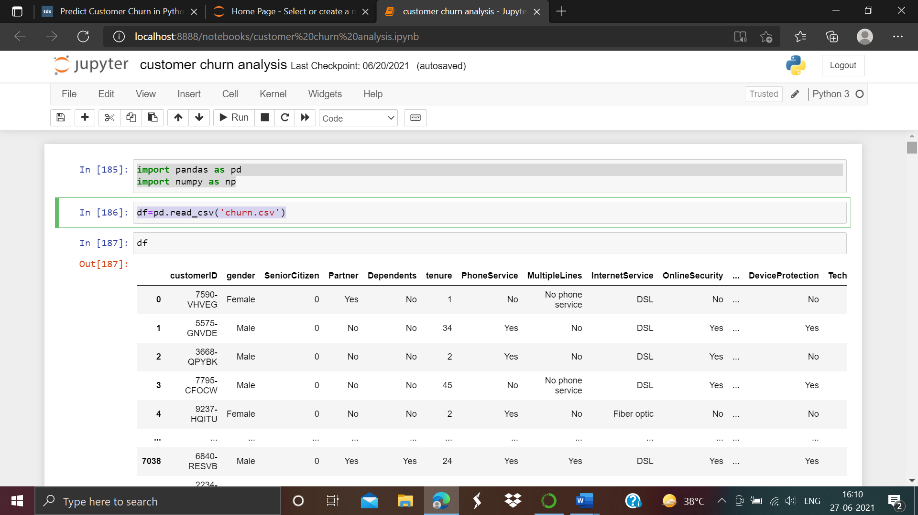

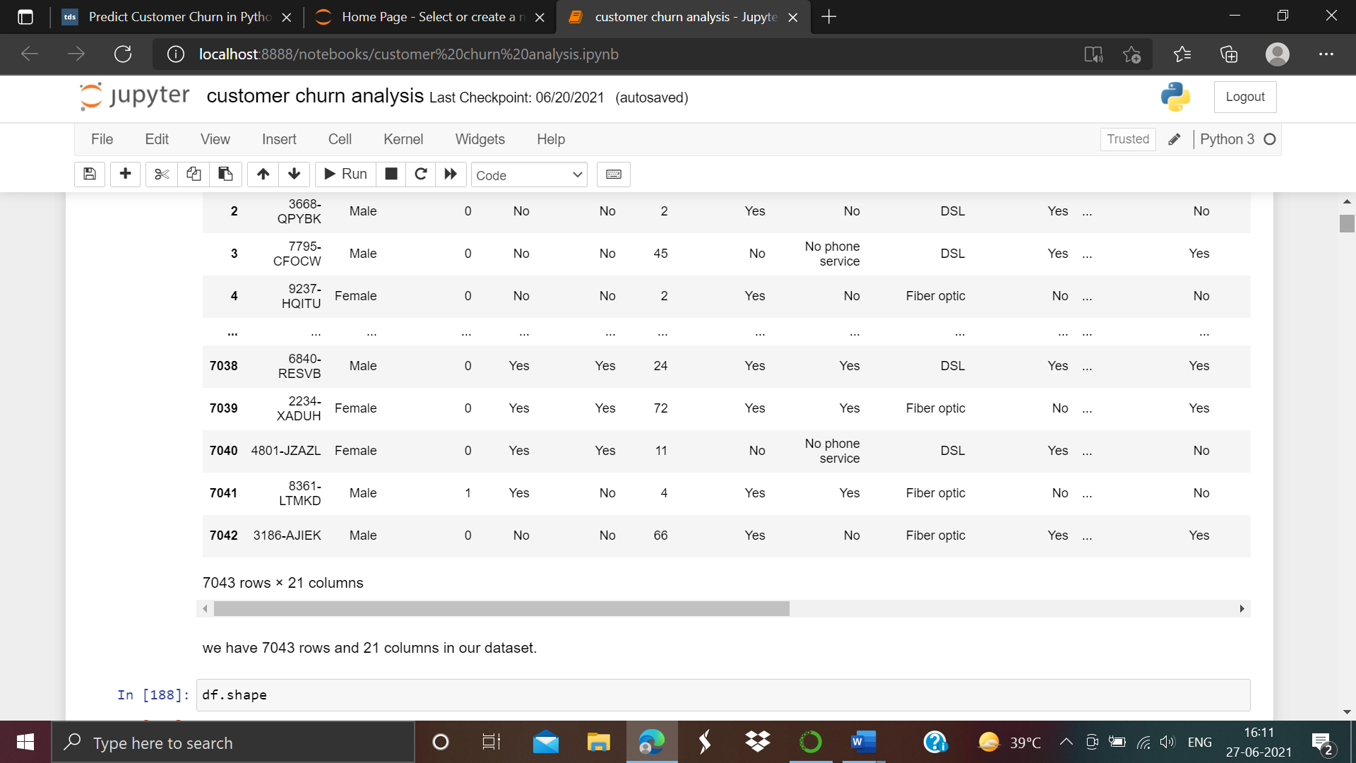

As we can see the there are 7043 rows and 21 columns in our dataset.

1. **Data Analysis**

df.head()

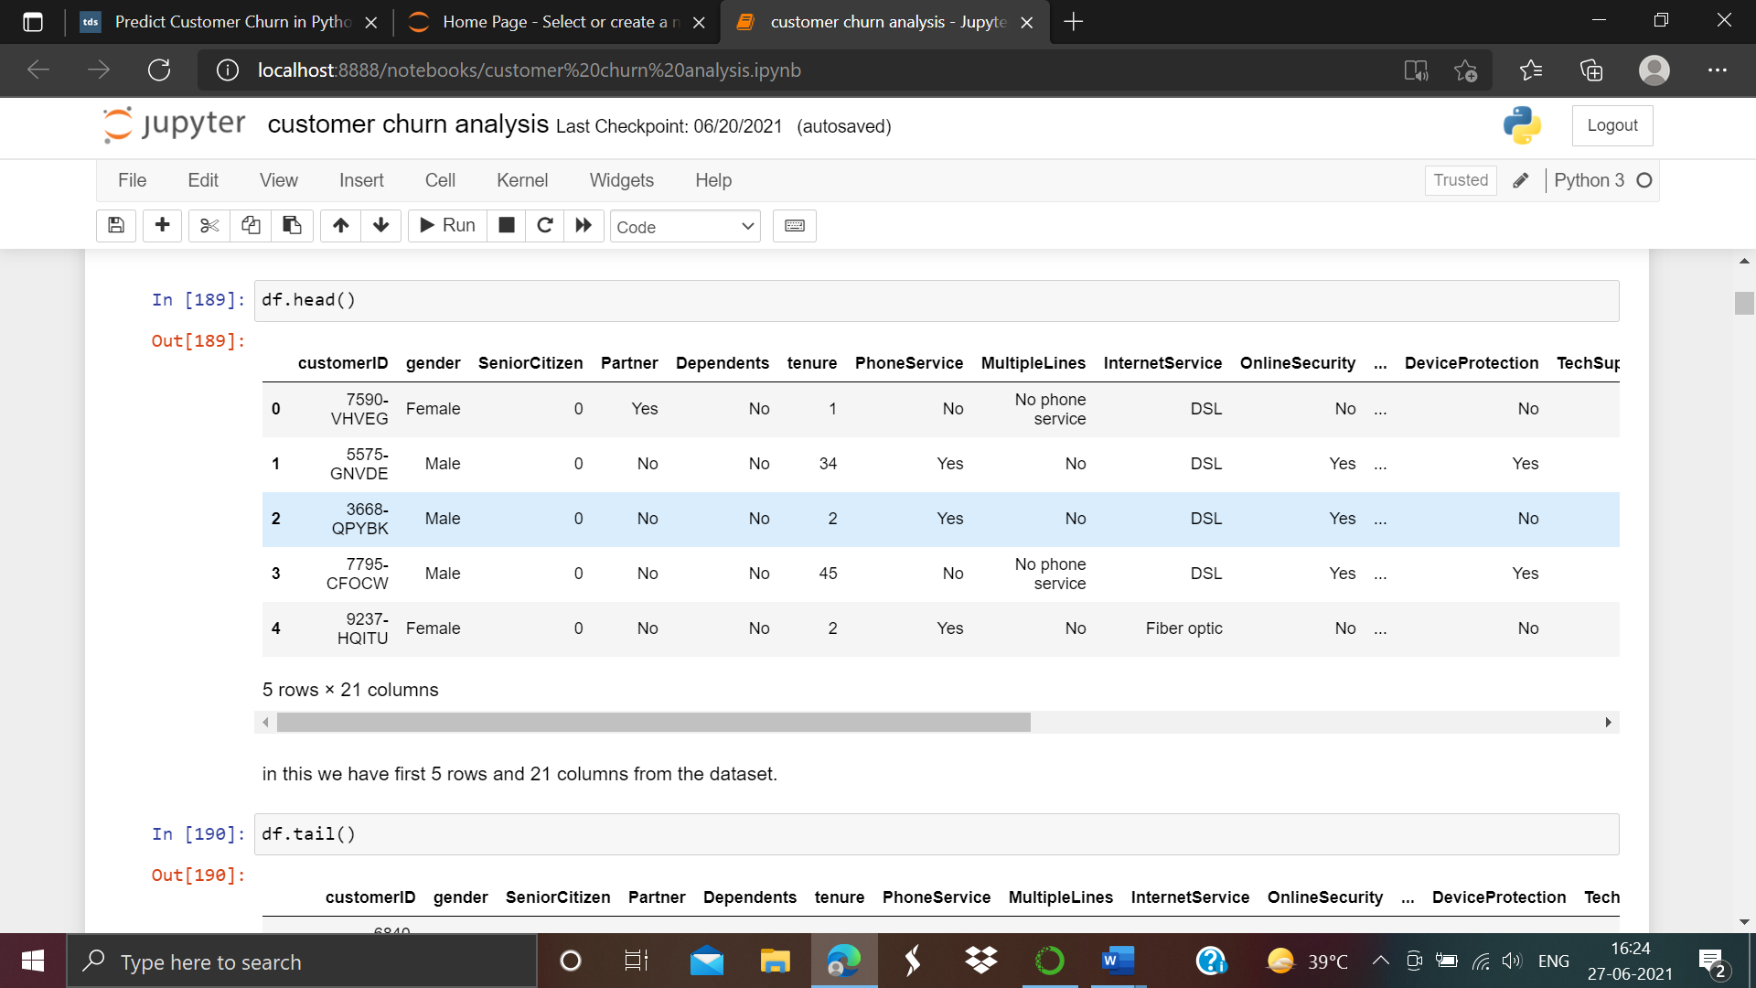

We have first 5 rows and 21 rows from the dataset.

**Checking missing values**

Now we check the null value present in our dataset. As screen shot is given below :-

df.isnull().sum()

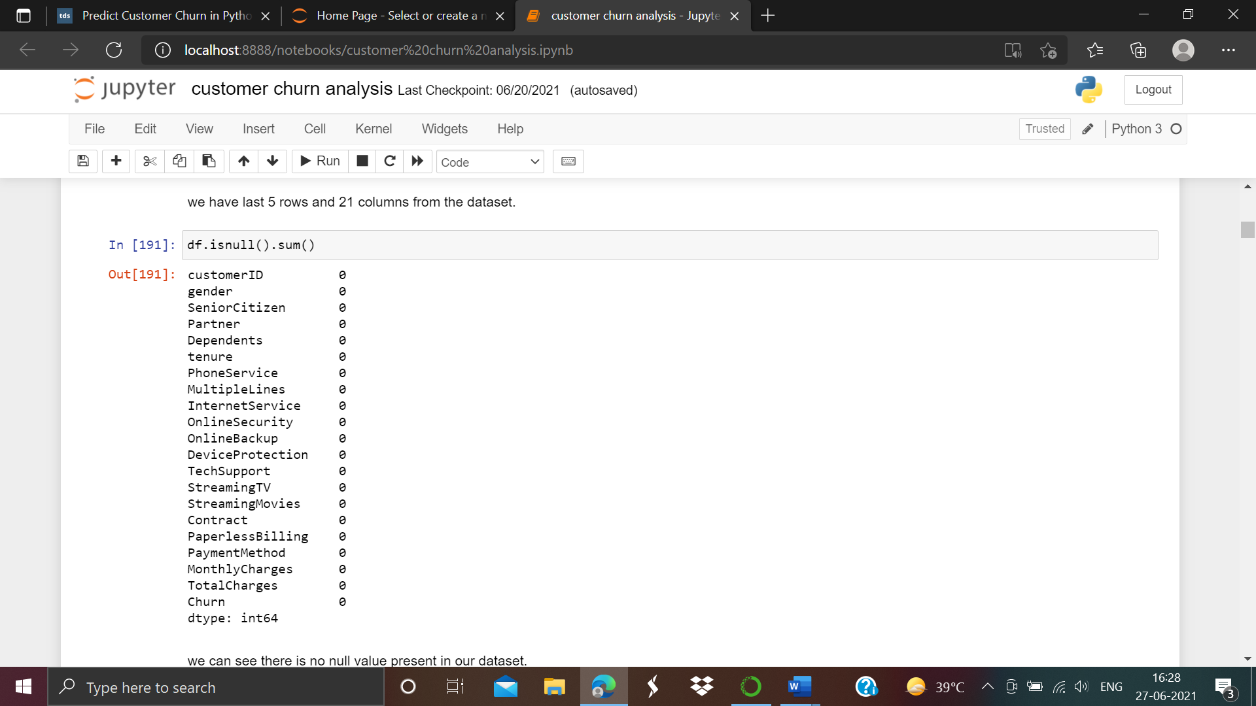

As we can see there is no null value present in our dataset.

**Checking the columns**

Now we have to check the columns present in our dataset. As shown below:-

df.columns

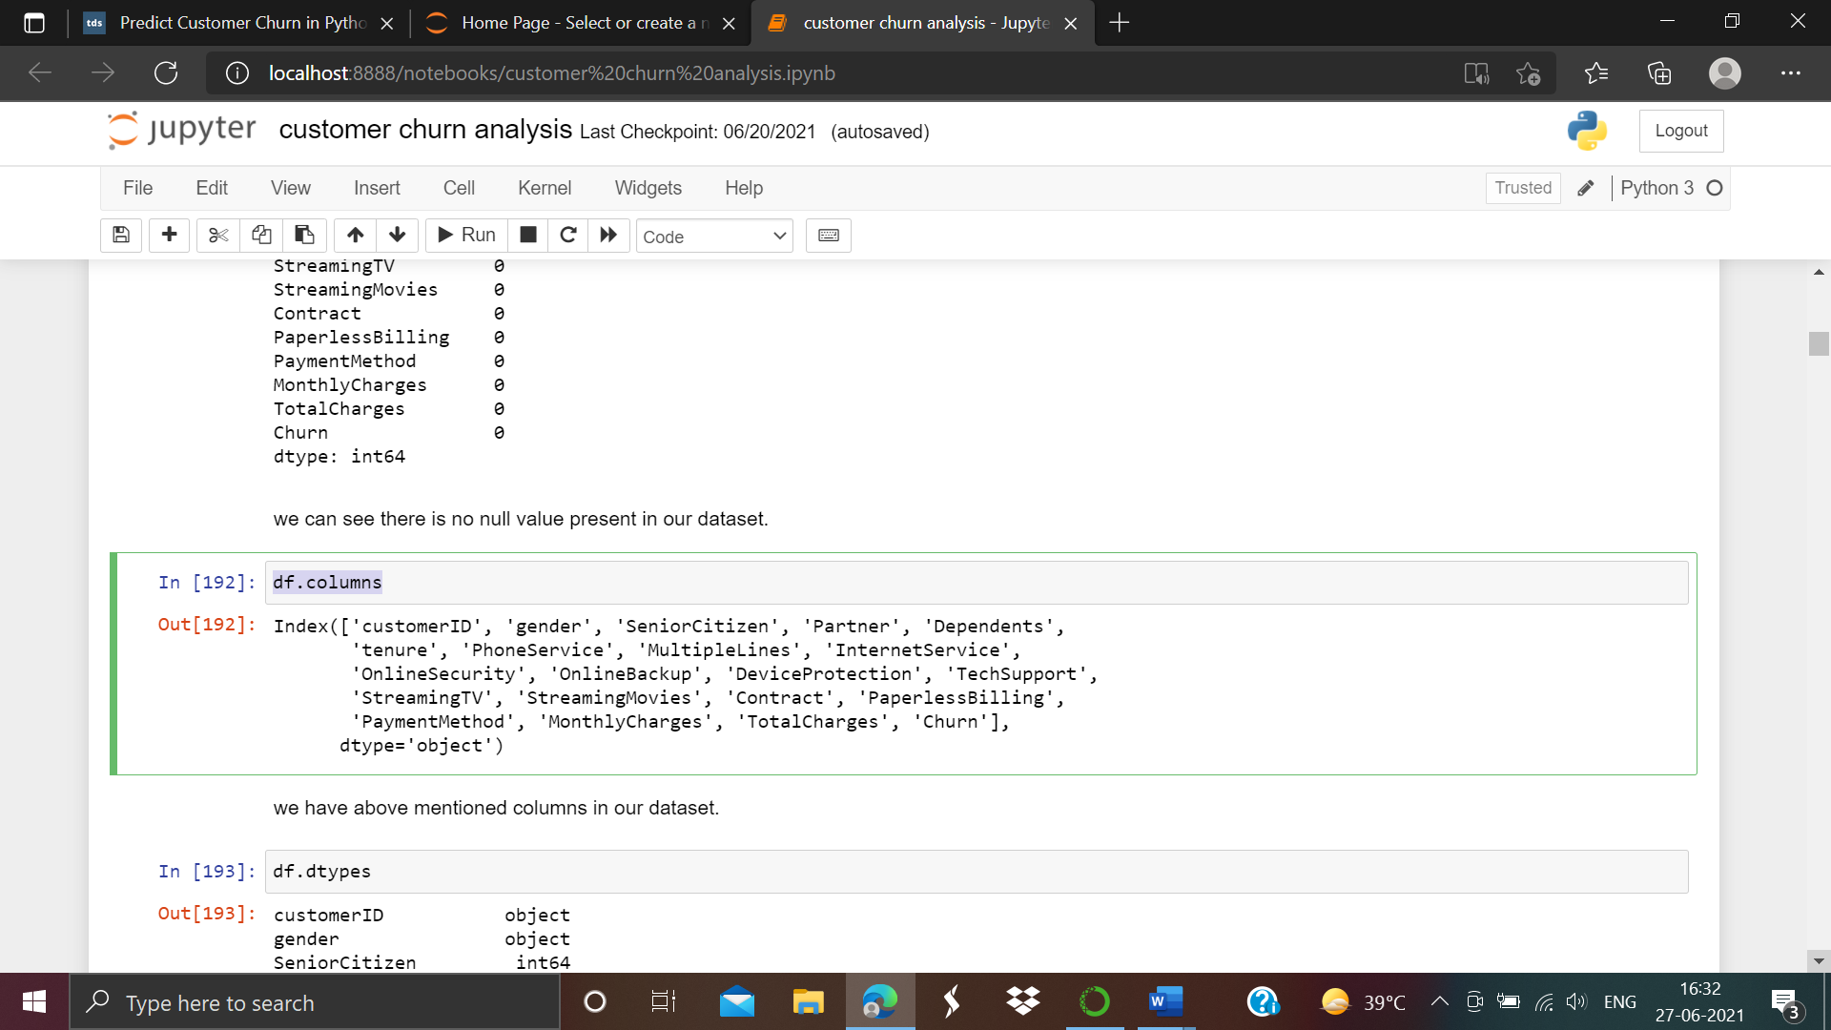

As we can see from the above we have above mentioned columns exists in our dataset.

**Checking dtypes**

df.dtypes

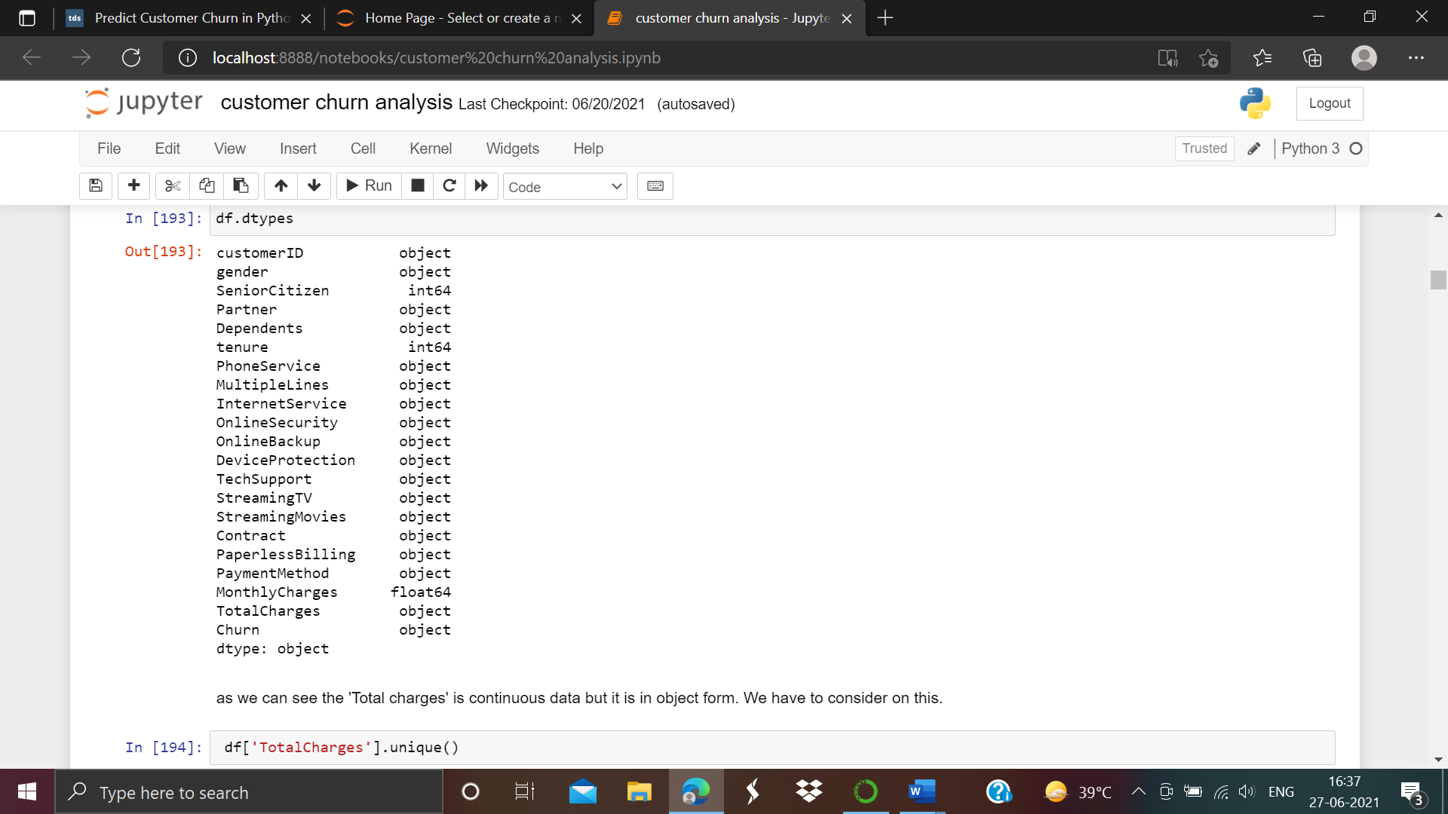

As we can see that total charges is continuous data type but it is in object in form. We have to consider on this.

df.describe()

As we can see the desription of our dataset screen shot attached below:-

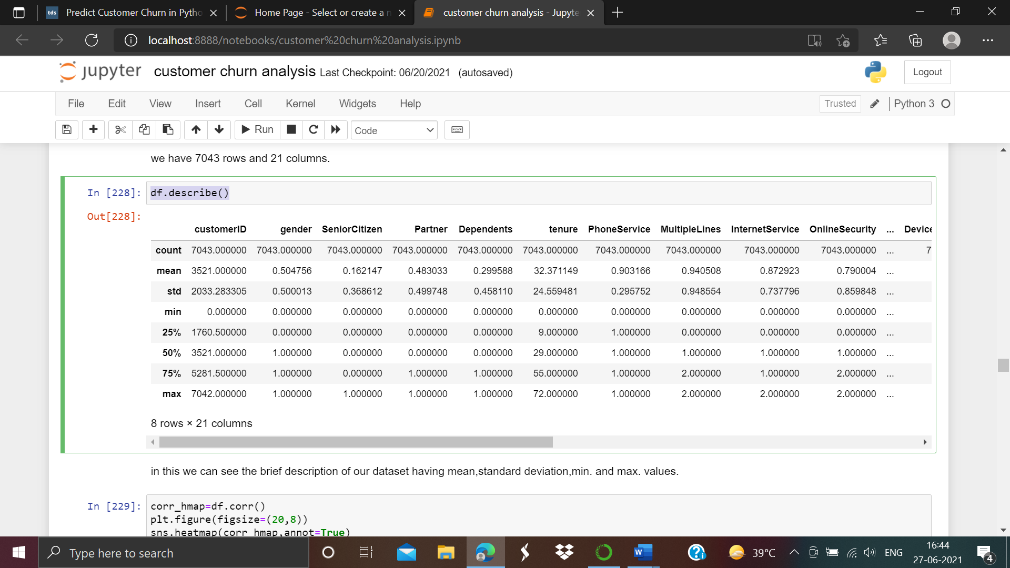

in this we can see the brief description of our dataset having mean,standard deviation,min. and max. values.

df.info()

In this we will see the nature of the columns present in our dataset. As screen shot attached below:-

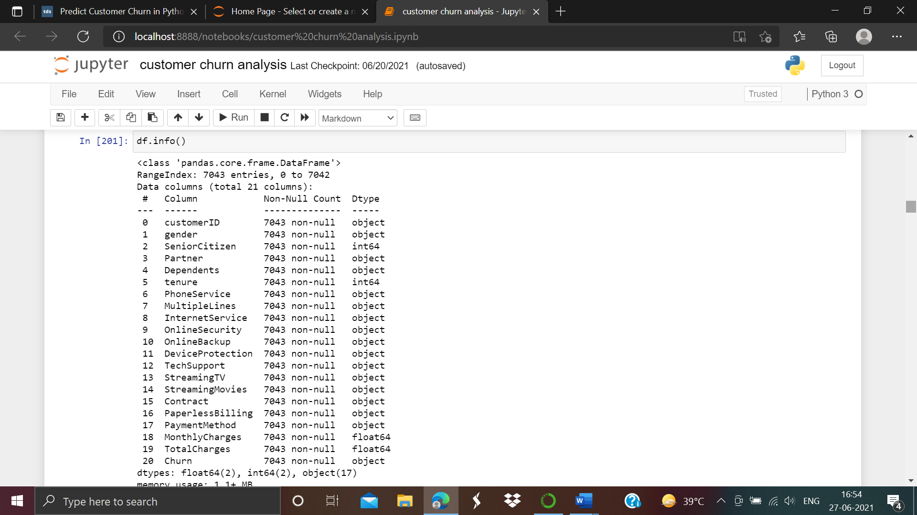

in this we can see the there are 17 object,2 integer and 2 float type coulmn features in our dataset.

1. **EDA Concluding Remarks**

Now we going to do Exploratory data analysis. In this we will discuss about nominal data and visualization of the data.

**Making Data Frame to nominal Data**

**df_visualization_nominal=df[['customerID', 'gender', 'SeniorCitizen', 'Partner', 'Dependents',**

**'tenure', 'PhoneService', 'MultipleLines', 'InternetService',**

**'OnlineSecurity', 'OnlineBackup', 'DeviceProtection', 'TechSupport',**

**'StreamingTV', 'StreamingMovies', 'Contract', 'PaperlessBilling',**

**'PaymentMethod', 'MonthlyCharges', 'TotalCharges', 'Churn']].copy()**

As we are showing the algorithms by screen shot attached below:-

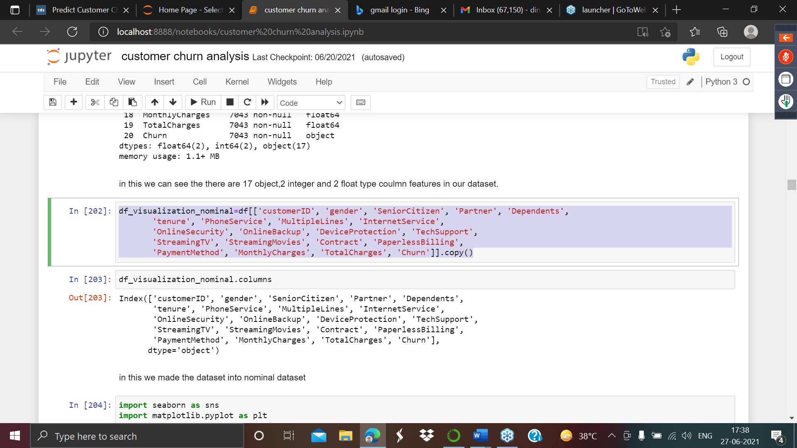

From the above we can see that we have convert the dataset into a nominal dataset.

For the nominal categorical data we will use count plot as it will give the frequency of the dataset of the columns. For data visualization we have to import the some libraries like

import seaborn as sns

import matplotlib.pyplot as plt

ax=sns.countplot(x='gender',data=df_visualization_nominal)

print(df_visualization_nominal['gender'].value_counts())

Let’s look about as screen shot attached below:-

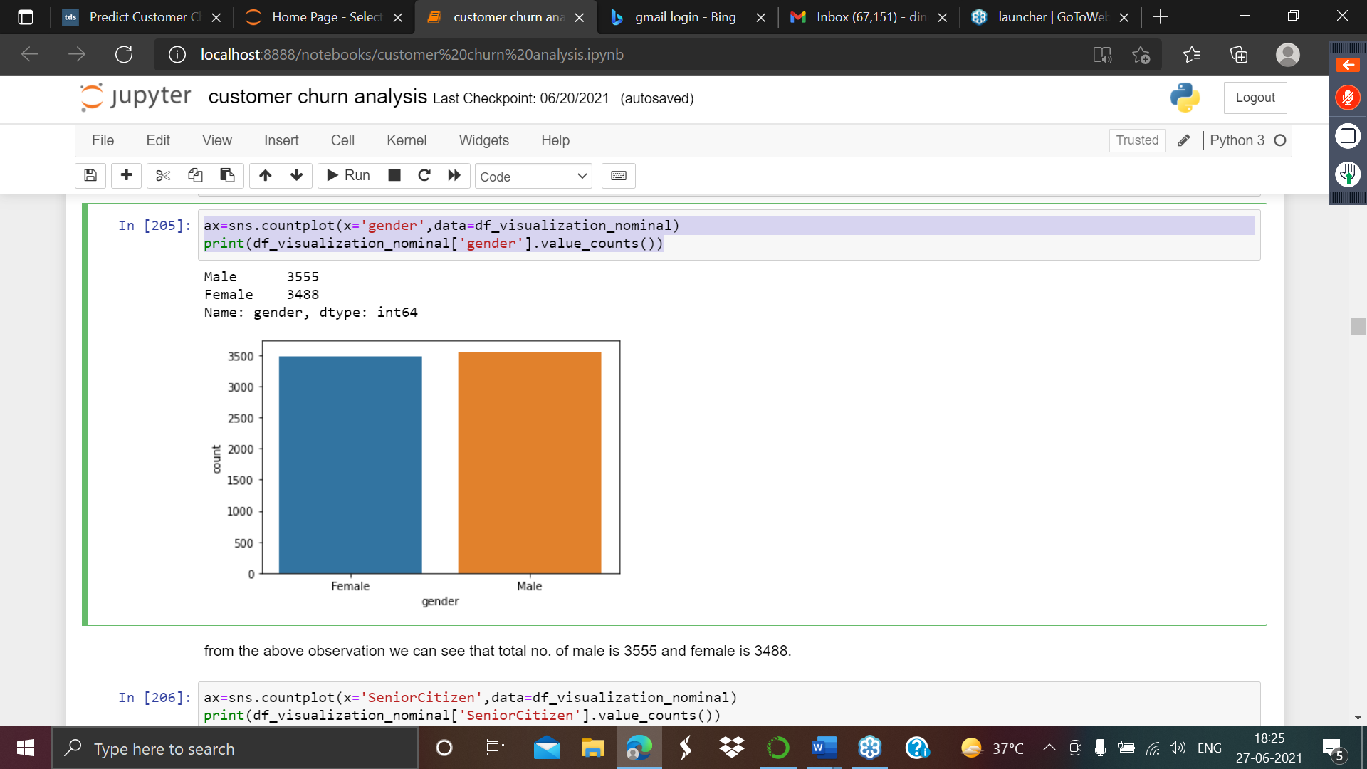

From the above we observed that total no. of male is 3555 and female is 3488.

ax=sns.countplot(x='SeniorCitizen',data=df_visualization_nominal)

print(df_visualization_nominal['SeniorCitizen'].value_counts())

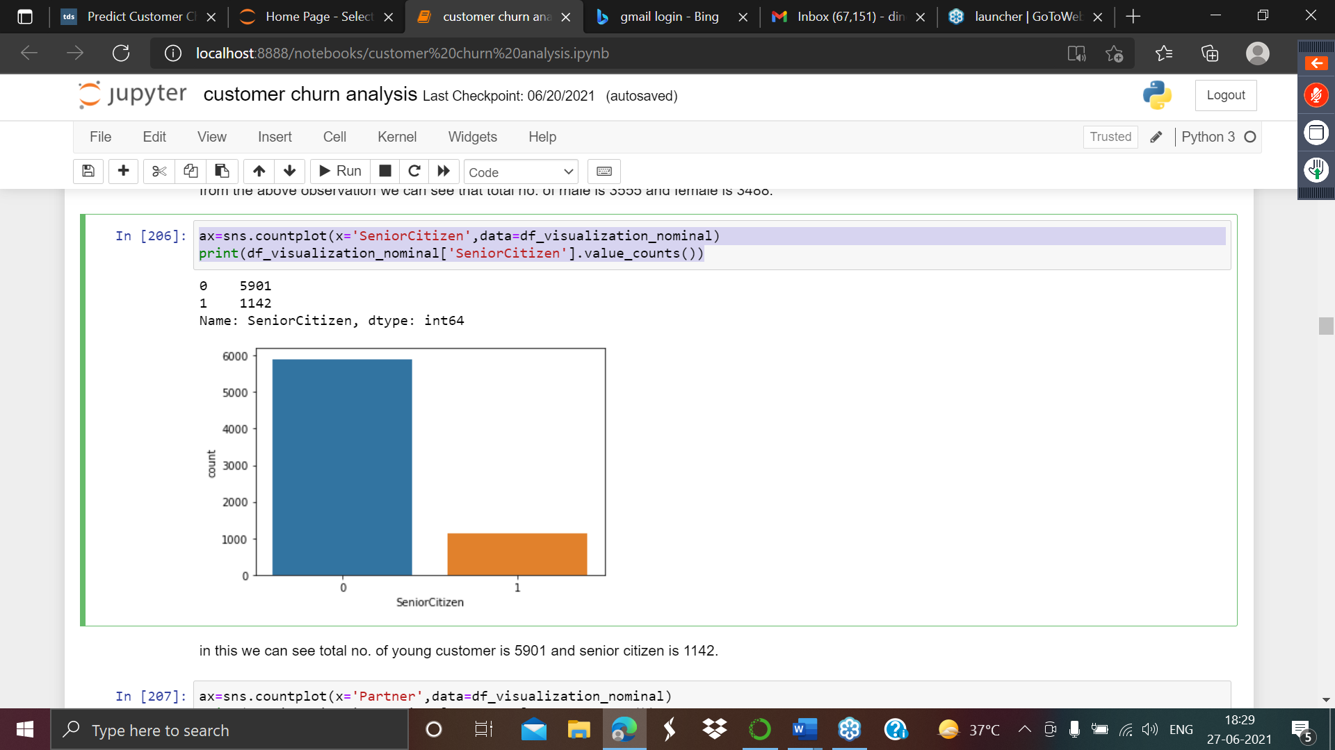

in this we can see total no. of young customer is 5901 and senior citizen is 1142.

ax=sns.countplot(x='Partner',data=df_visualization_nominal)

print(df_visualization_nominal['Partner'].value_counts())

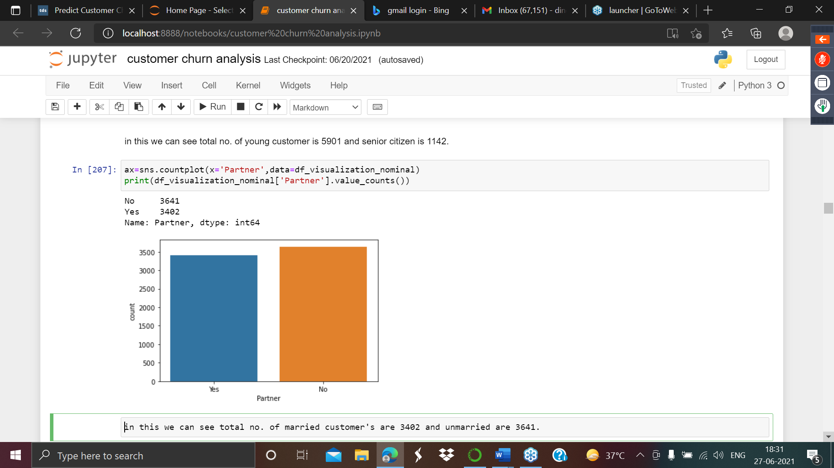

in this we can see total no. of married customer's are 3402 and unmarried are 3641.

ax=sns.countplot(x='Dependents',data=df_visualization_nominal)

print(df_visualization_nominal['Dependents'].value_counts())

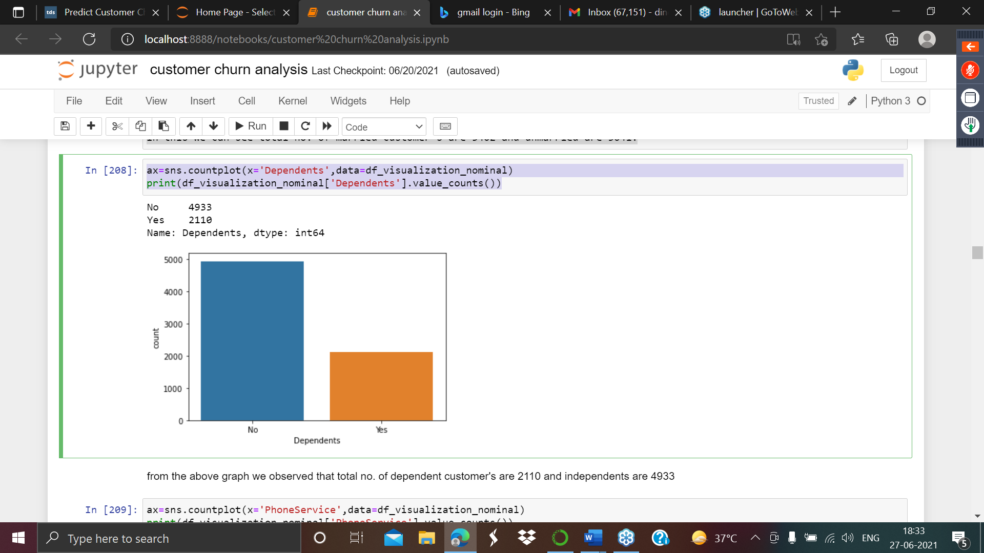

from the above graph we observed that total no. of dependent customer's are 2110 and independents are 4933.

ax=sns.countplot(x='PhoneService',data=df_visualization_nominal)

print(df_visualization_nominal['PhoneService'].value_counts())

as screen shot attached below:-

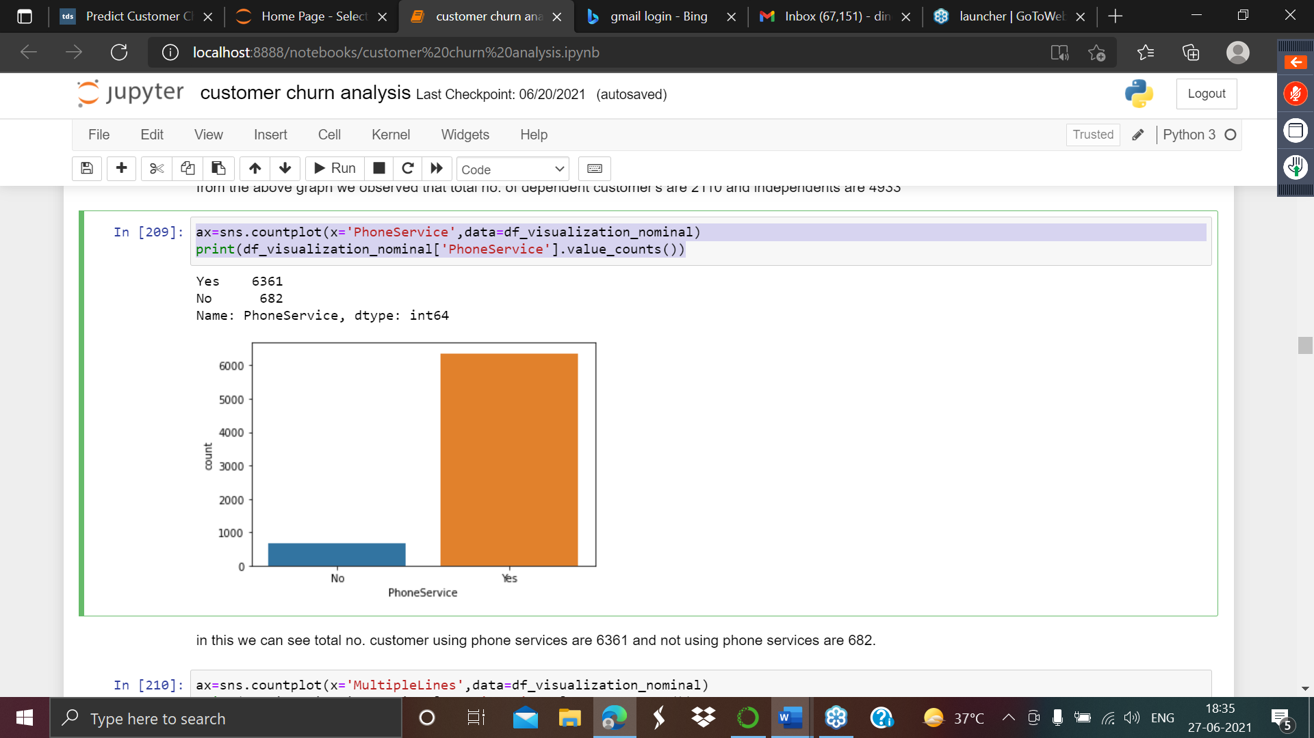

in this we can see total no. customer using phone services are 6361 and not using phone services are 682.

ax=sns.countplot(x='MultipleLines',data=df_visualization_nominal)

print(df_visualization_nominal['MultipleLines'].value_counts())

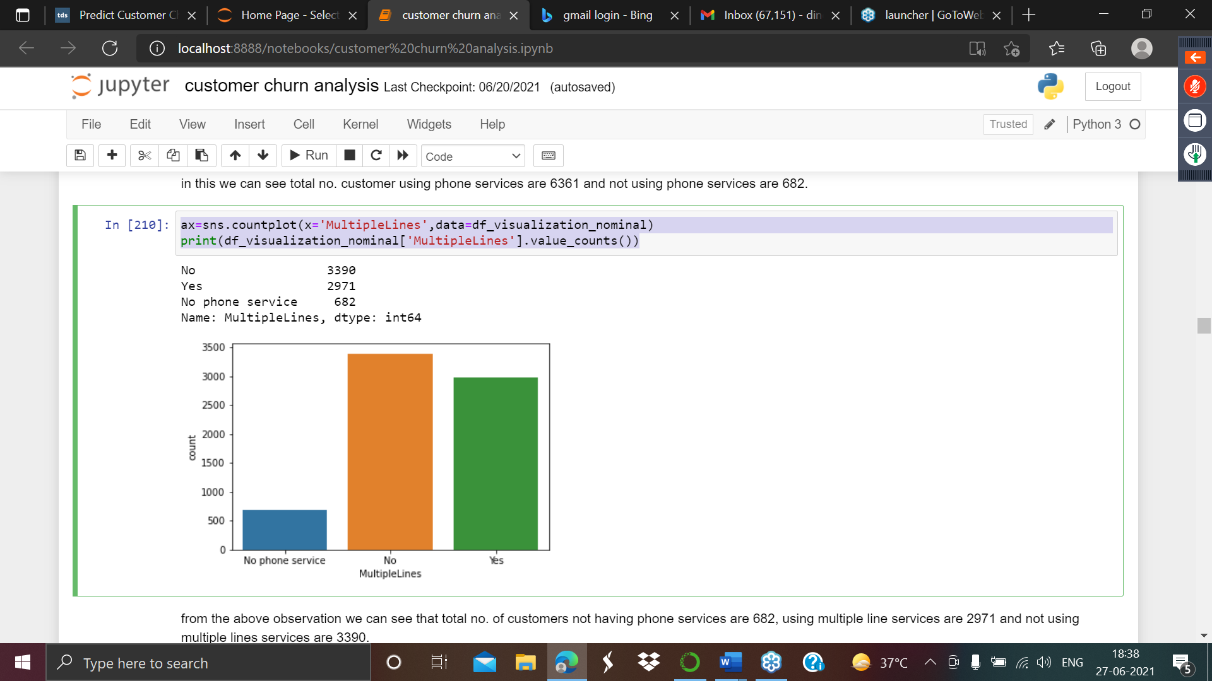

from the above observation we can see that total no. of customers not having phone services are 682, using multiple line services are 2971 and not using multiple lines services are 3390.

ax=sns.countplot(x='InternetService',data=df_visualization_nominal)

print(df_visualization_nominal['InternetService'].value_counts())

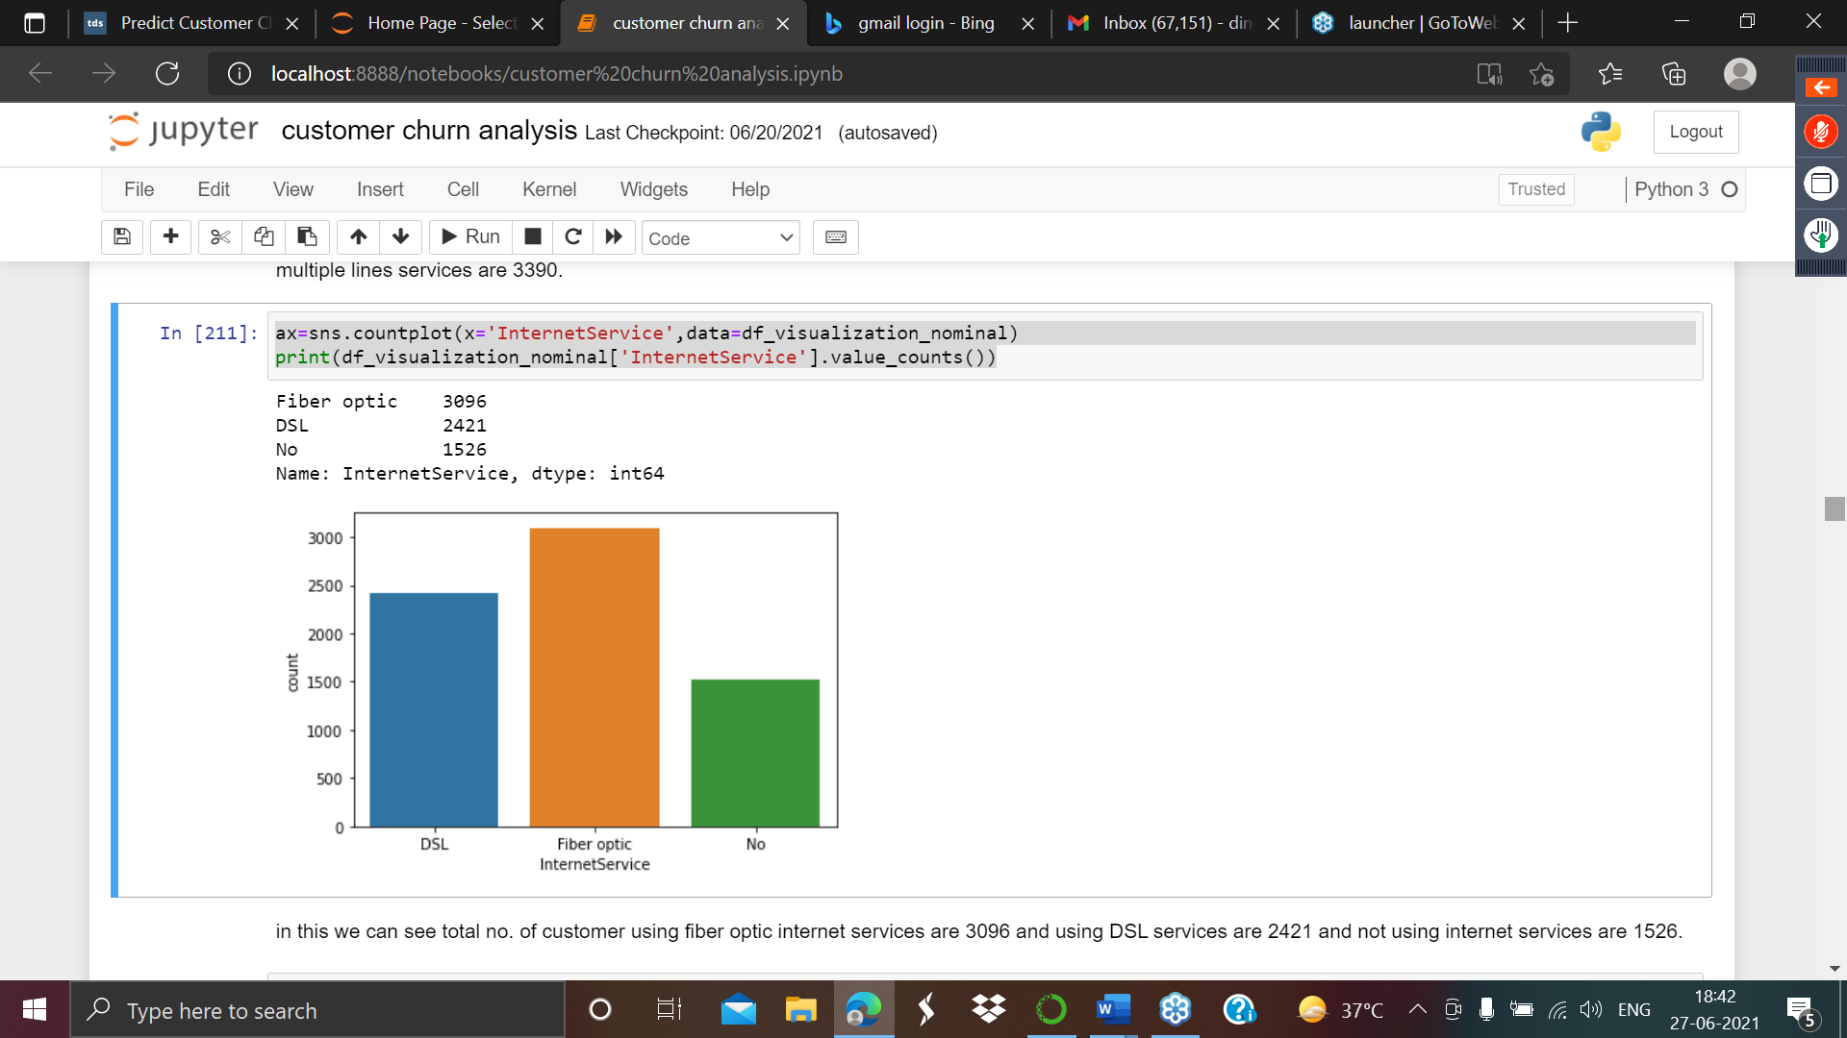

in this we can see total no. of customer using fiber optic internet services are 3096 and using DSL services are 2421 and not using internet services are 1526.

ax=sns.countplot(x='DeviceProtection',data=df_visualization_nominal)

print(df_visualization_nominal['DeviceProtection'].value_counts())

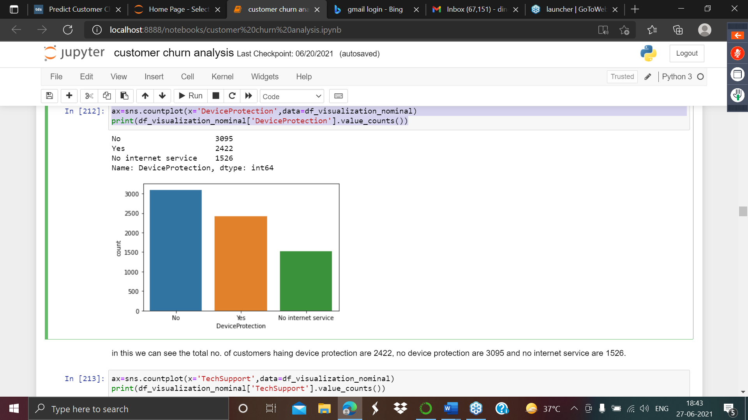

in this we can see the total no. of customers having device protection are 2422, no device protection are 3095 and no internet service are 1526.

ax=sns.countplot(x='TechSupport',data=df_visualization_nominal)

print(df_visualization_nominal['TechSupport'].value_counts())

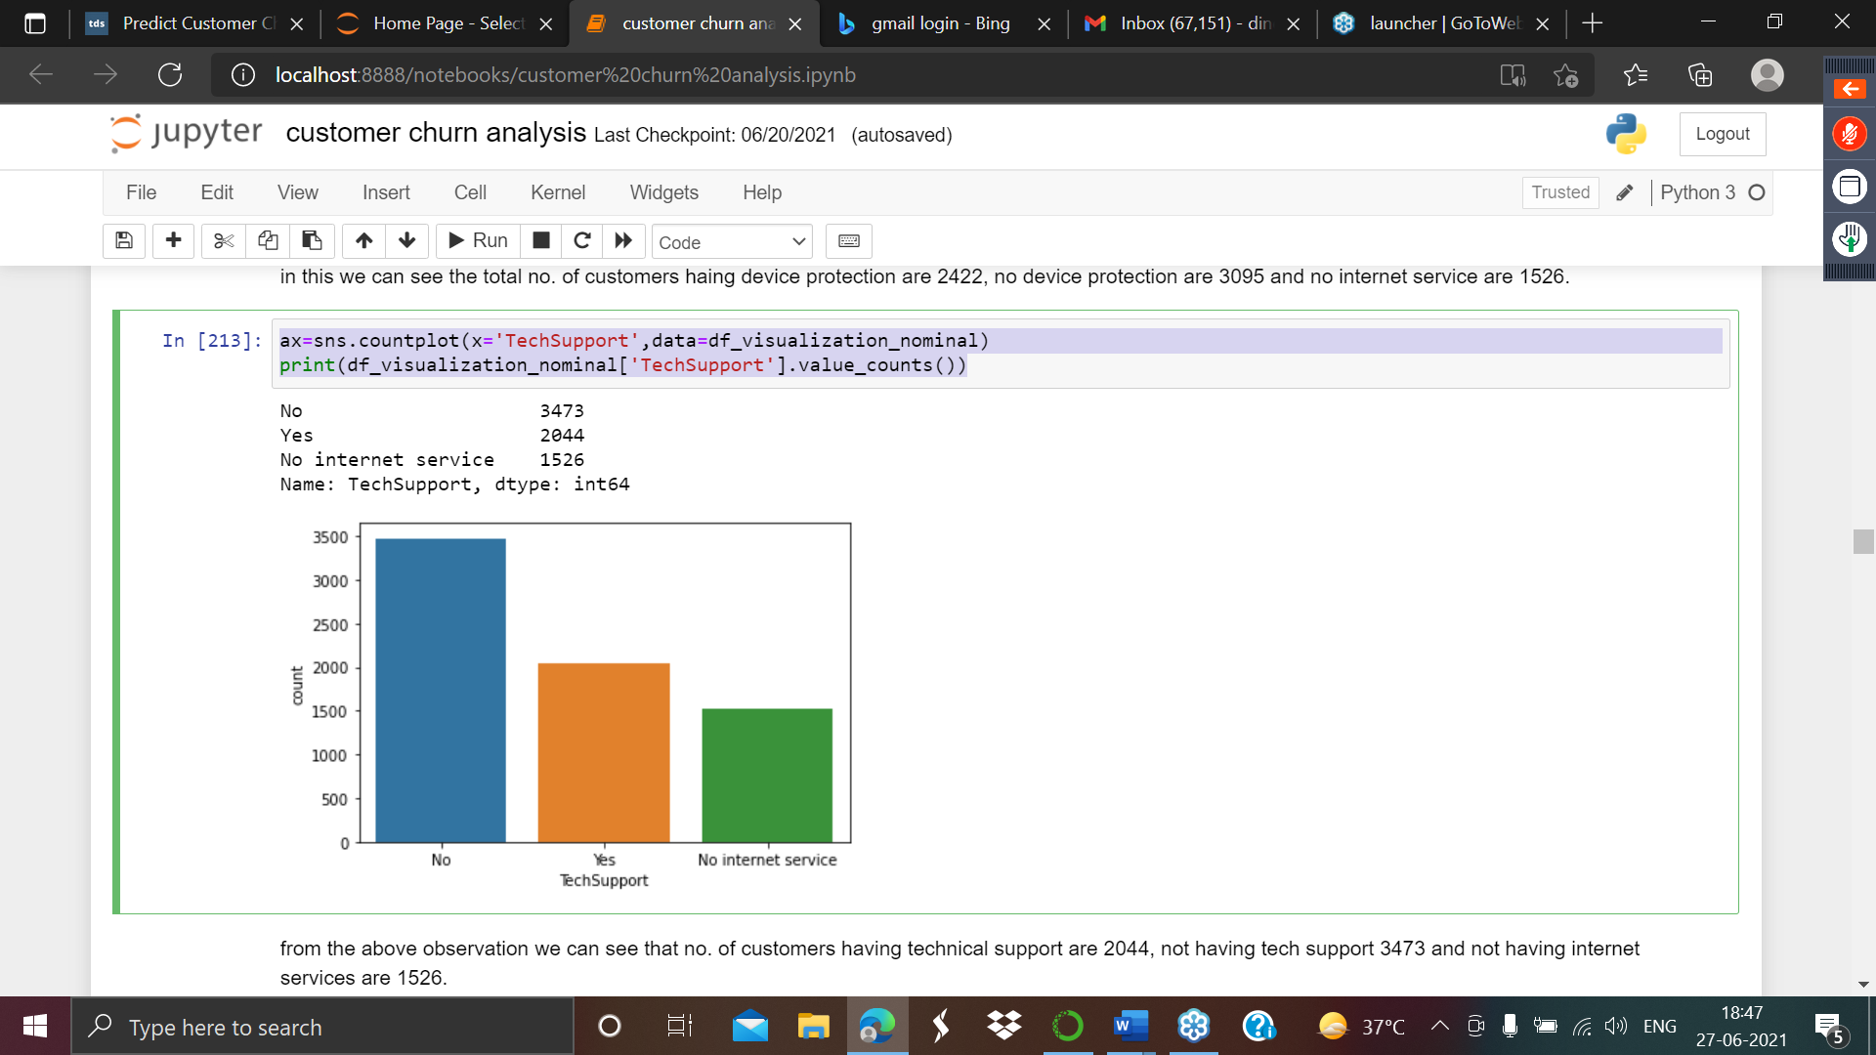

from the above observation we can see that no. of customers having technical support are 2044, not having tech support 3473 and not having internet services are 1526.

ax=sns.countplot(x='StreamingTV',data=df_visualization_nominal)

print(df_visualization_nominal['StreamingTV'].value_counts()

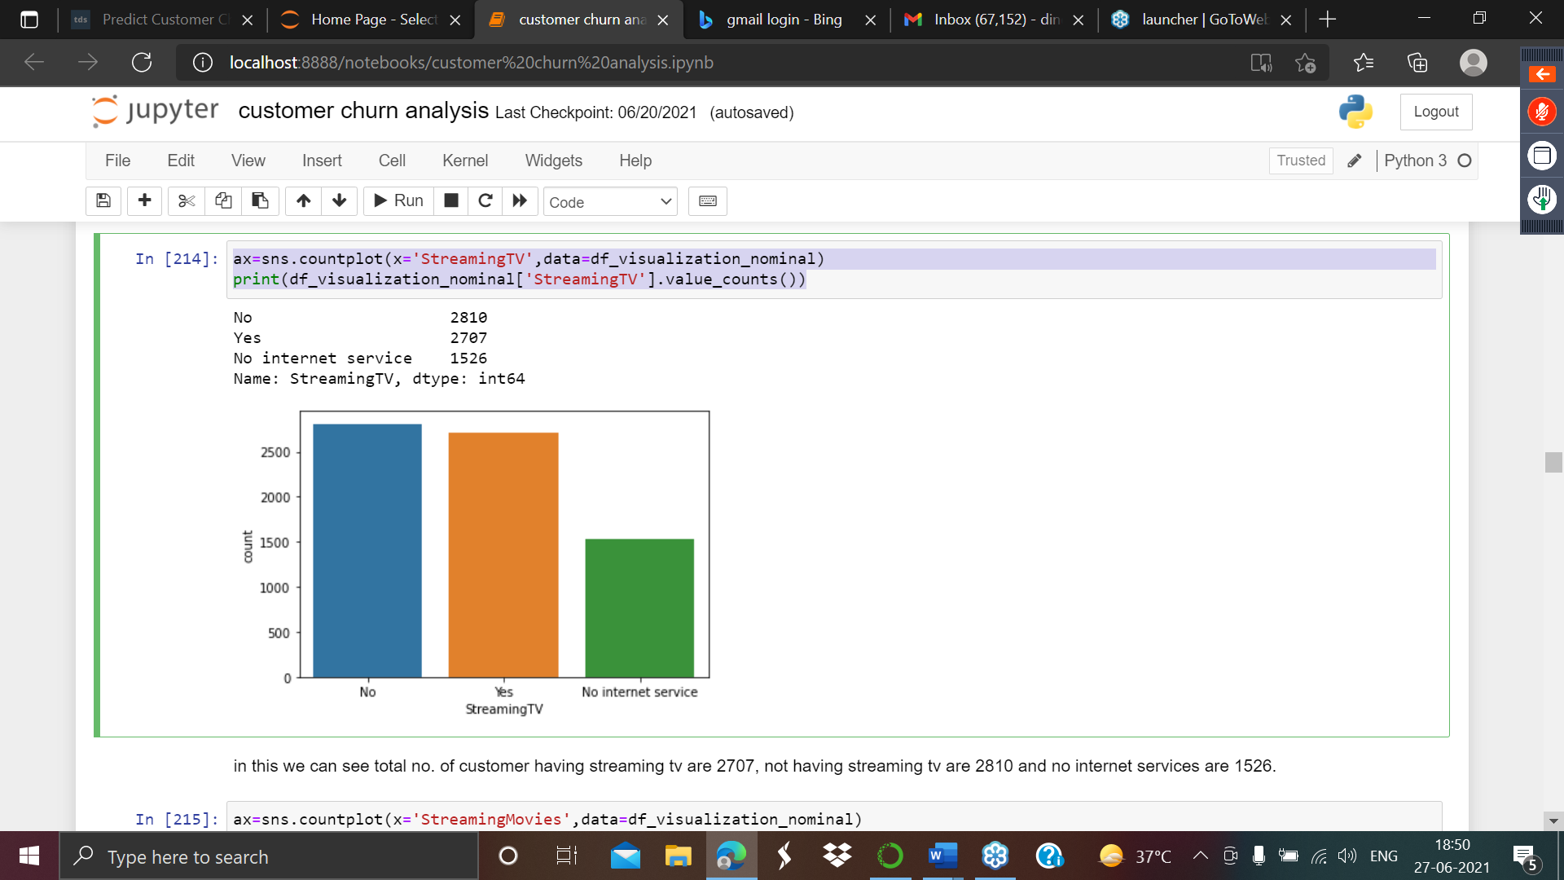

in this we can see total no. of customer having streaming tv are 2707, not having streaming tv are 2810 and no internet services are 1526.

ax=sns.countplot(x='StreamingMovies',data=df_visualization_nominal)

print(df_visualization_nominal['StreamingMovies'].value_counts())

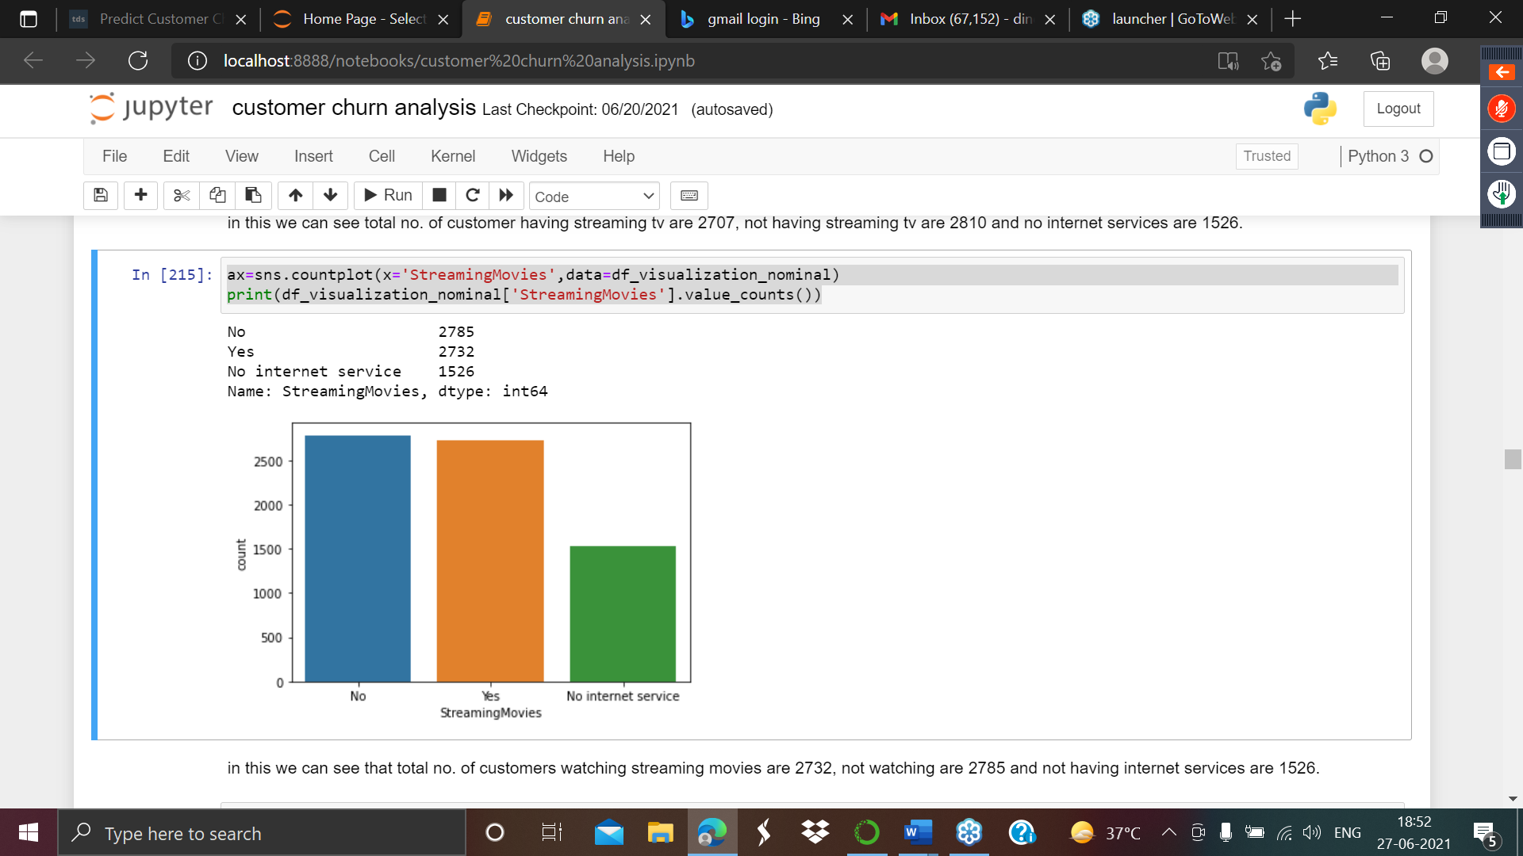

in this we can see that total no. of customers watching streaming movies are 2732, not watching are 2785 and not having internet services are 1526.

ax=sns.countplot(x='Contract',data=df_visualization_nominal)

print(df_visualization_nominal['Contract'].value_counts())

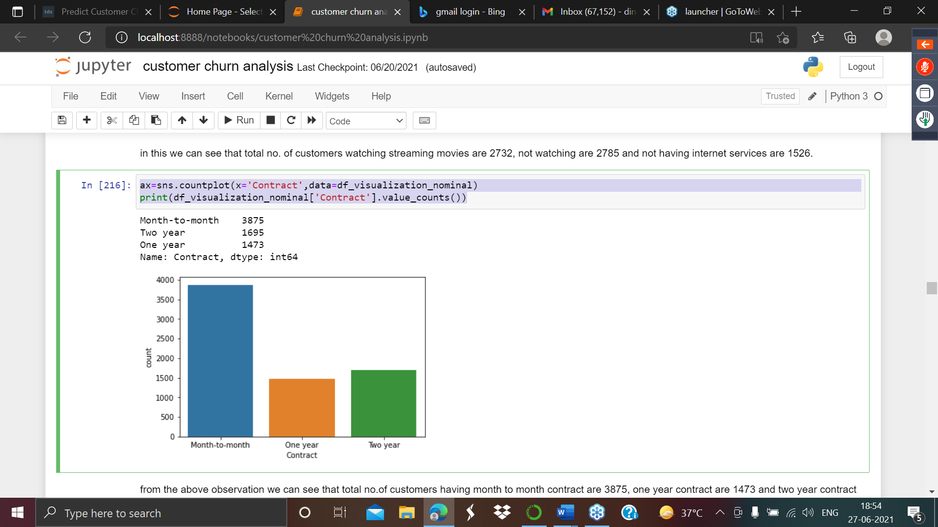

from the above observation we can see that total no.of customers having month to month contract are 3875, one year contract are 1473 and two year contract are 1695.

ax=sns.countplot(x='PaperlessBilling',data=df_visualization_nominal)

print(df_visualization_nominal['PaperlessBilling'].value_counts())

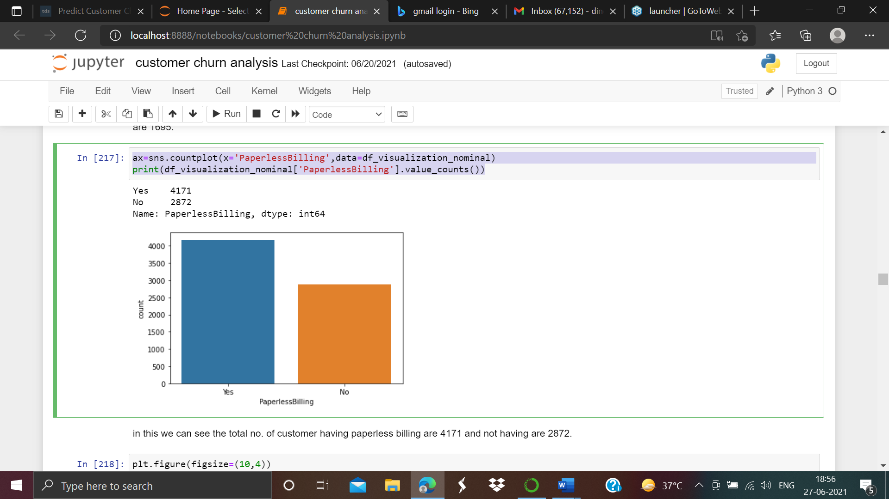

In this we can see the total no. of customer having paperless billing are 4171 and not having are 2872.

plt.figure(figsize=(10,4))

ax=sns.countplot(x='PaymentMethod',data=df_visualization_nominal)

print(df_visualization_nominal['PaymentMethod'].value_counts())

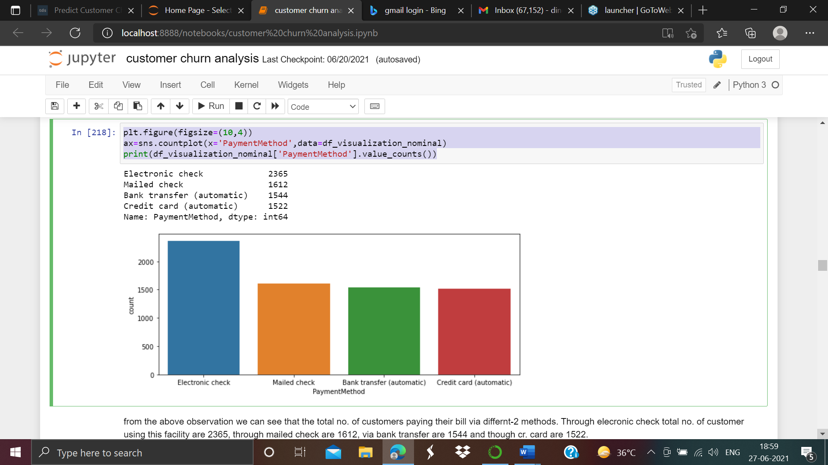

from the above observation we can see that the total no. of customers paying their bill via differnt-2 methods. Through electronic check total no. of customer using this facility are 2365, through mailed check are 1612, via bank transfer are 1544 and though cr. card are 1522.

ax=sns.countplot(x='Churn',data=df_visualization_nominal)

print(df_visualization_nominal['Churn'].value_counts())

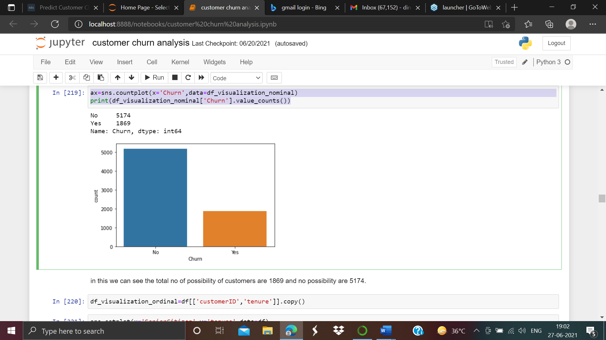

in this we can see the total no of possibility of customers are 1869 and no possibility are 5174.

**Making the Data Frame of the ordinal Data**

df_visualization_ordinal=df[['customerID','tenure']].copy()

sns.catplot(x='SeniorCitizen',y='tenure',data=df)

as screen shot attached is given below:-

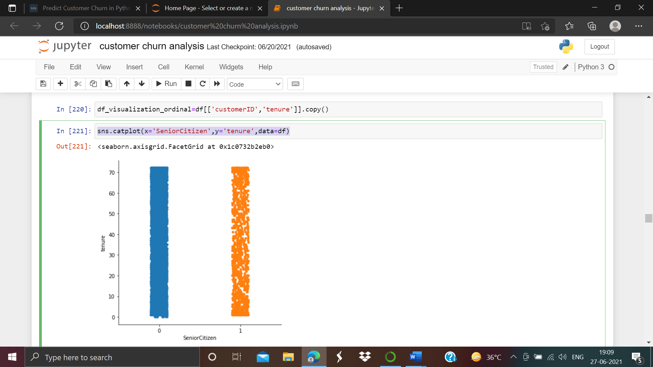

In this we can see the correlation between the senior citizen and tenure.

**Checking the distribution of the continuous value of the float type columns.**

df_visualization_continuous=df[['MonthlyCharges','TotalCharges']].copy()

sns.distplot(df_visualization_continuous['TotalCharges'],kde=True)

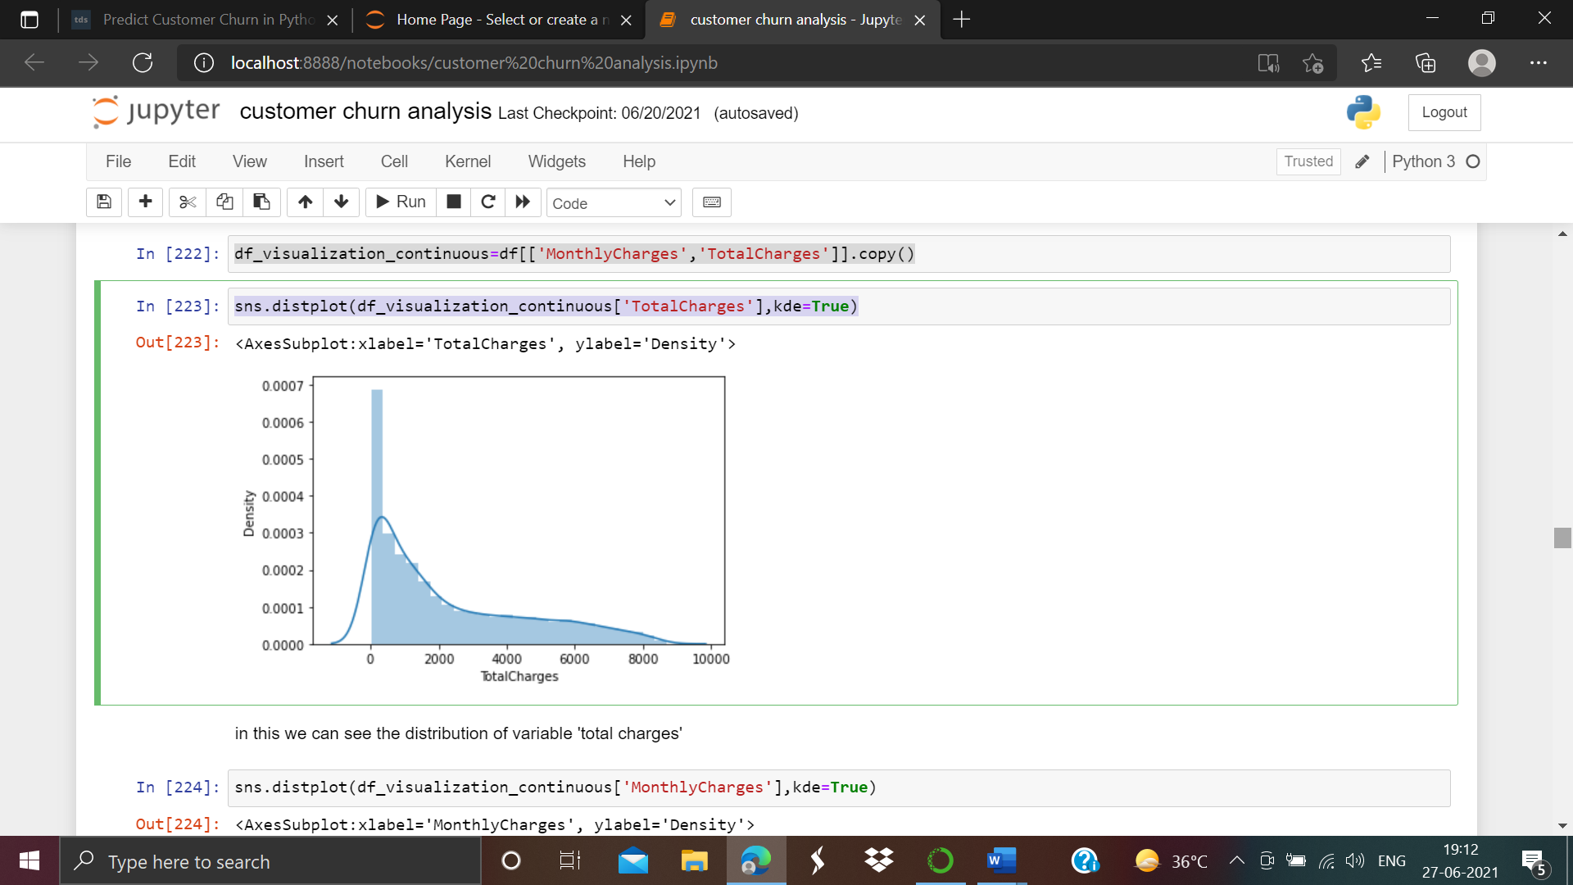

in this we can see the distribution of variable 'total charges'

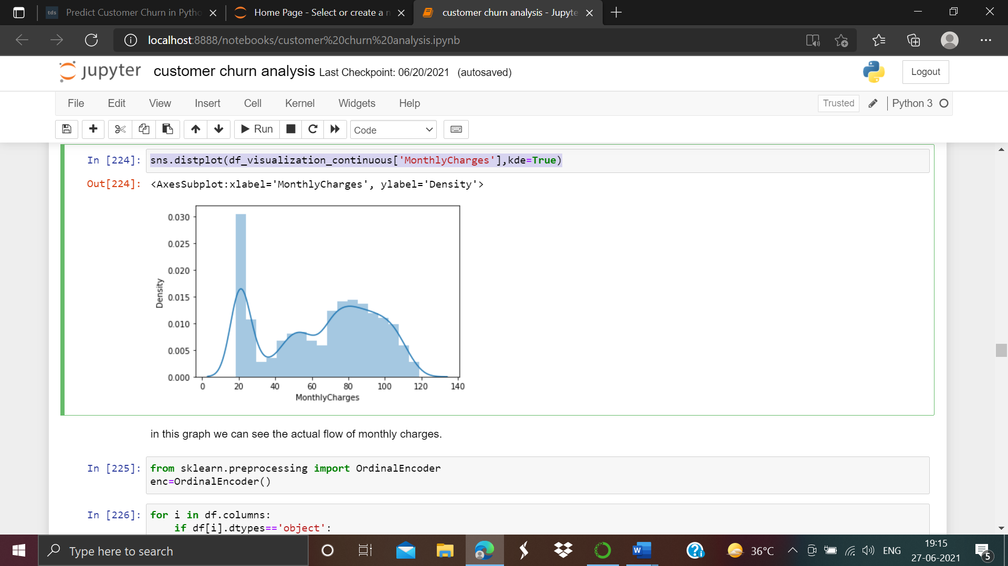

As we can see that actual flow of monthly charges.

Visualization part is completed

Since the dataset has a lot of string values. We will use the encoding techniques to convert the string data to numerical one.

1. **Preprocessing pipeline**:-

First of all we have to looking for Label encoding the our dataset. Machine Learning algorithms can typically only have numerical values as their independent variables. Hence label encoding is quite pivotal as they encode categorical labels with appropriate numerical values. Here we are label encoding all categorical variables that have only two unique values. Any categorical variable that has more than two unique values are dealt with Label Encoding and one-hot Encoding in the subsequent sections.

We have to encode our Data Frame.Let’s apply the label encoder to our dataset as screen shot attached below:-

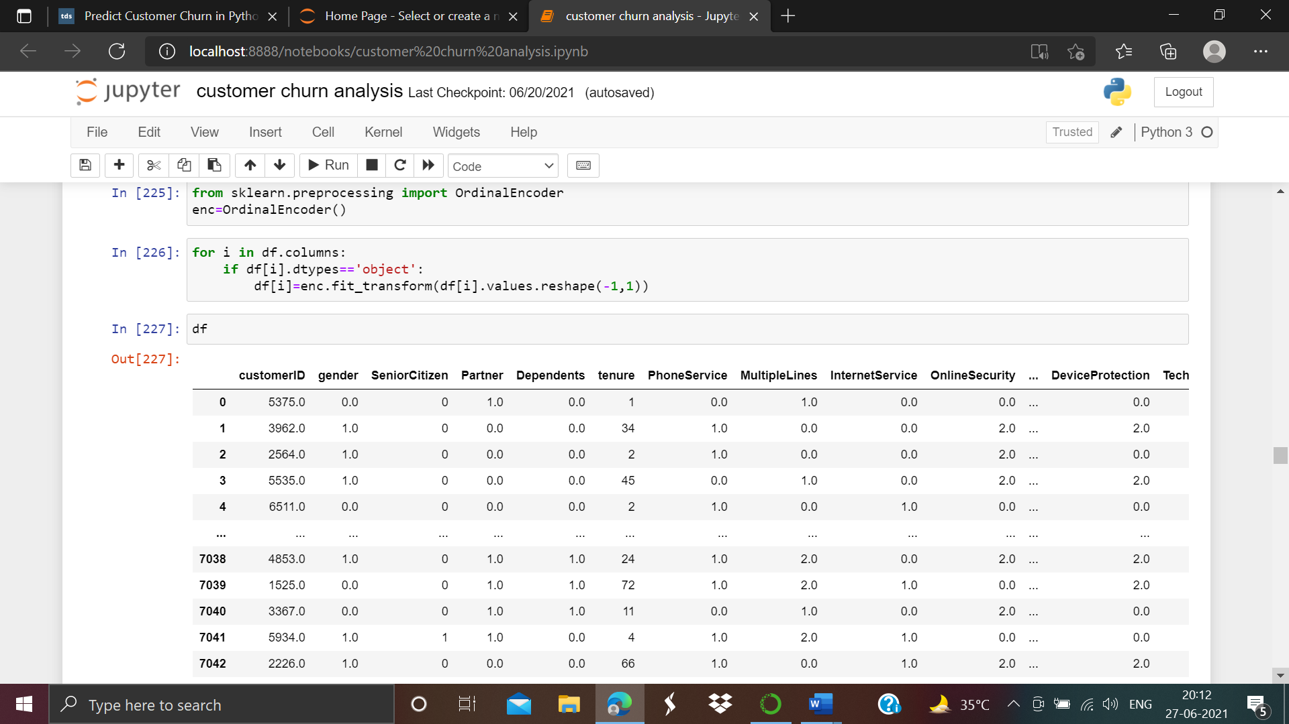

After encoding the dataframe we have move to move on correlation between the columns of the dataset.

Now we are going to create the correlation of the columns with the target columns. As shown below:-

df.corr()

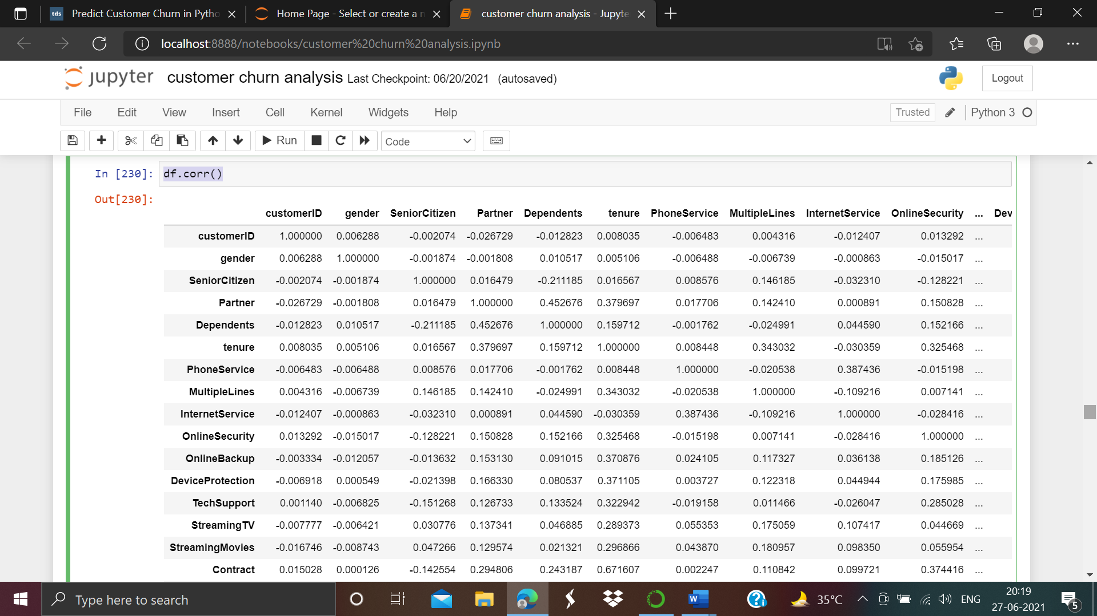

In this we can see the how columns variables correlated with targeted columns respectively with each other. For better explanation we need to use heatmap as shown below:-

corr_hmap=df.corr()

plt.figure(figsize=(20,8))

sns.heatmap(corr_hmap,annot=True)

plt.show()

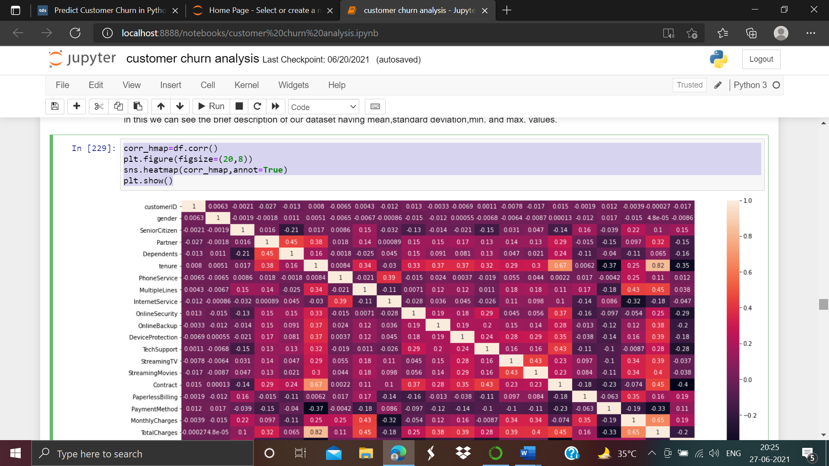

from the above figure we observed that payment method and tenure features are highly negatively correlated with each other having value -0.37

**Checking the columns positively and negatively correlated**

plt.figure(figsize=(22,7))

df.corr()['TotalCharges'].sort_values(ascending=False).drop(['TotalCharges']).plot(kind='bar',color='c')

plt.xlabel('Feature',fontsize=14)

plt.ylabel('column with target names',fontsize=14)

plt.title('correlation',fontsize=18)

plt.show()

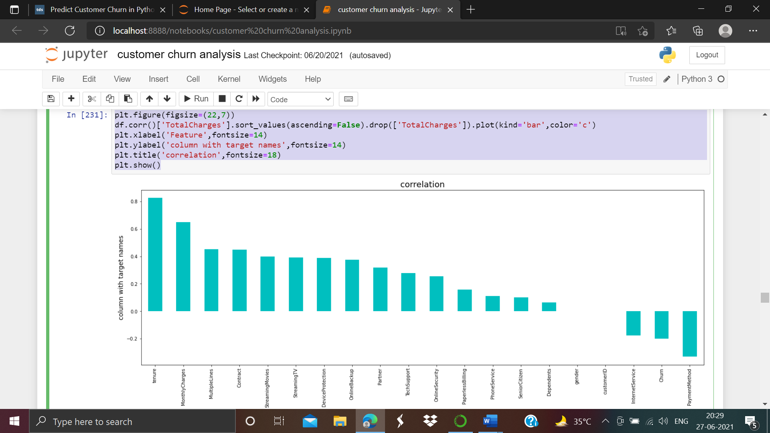

As from the above observations we can see that columns are positively and negatively correlated with the target columns.

**Skewness**

Now it’s a time to determine the skewness of the dataset.

df.skew()

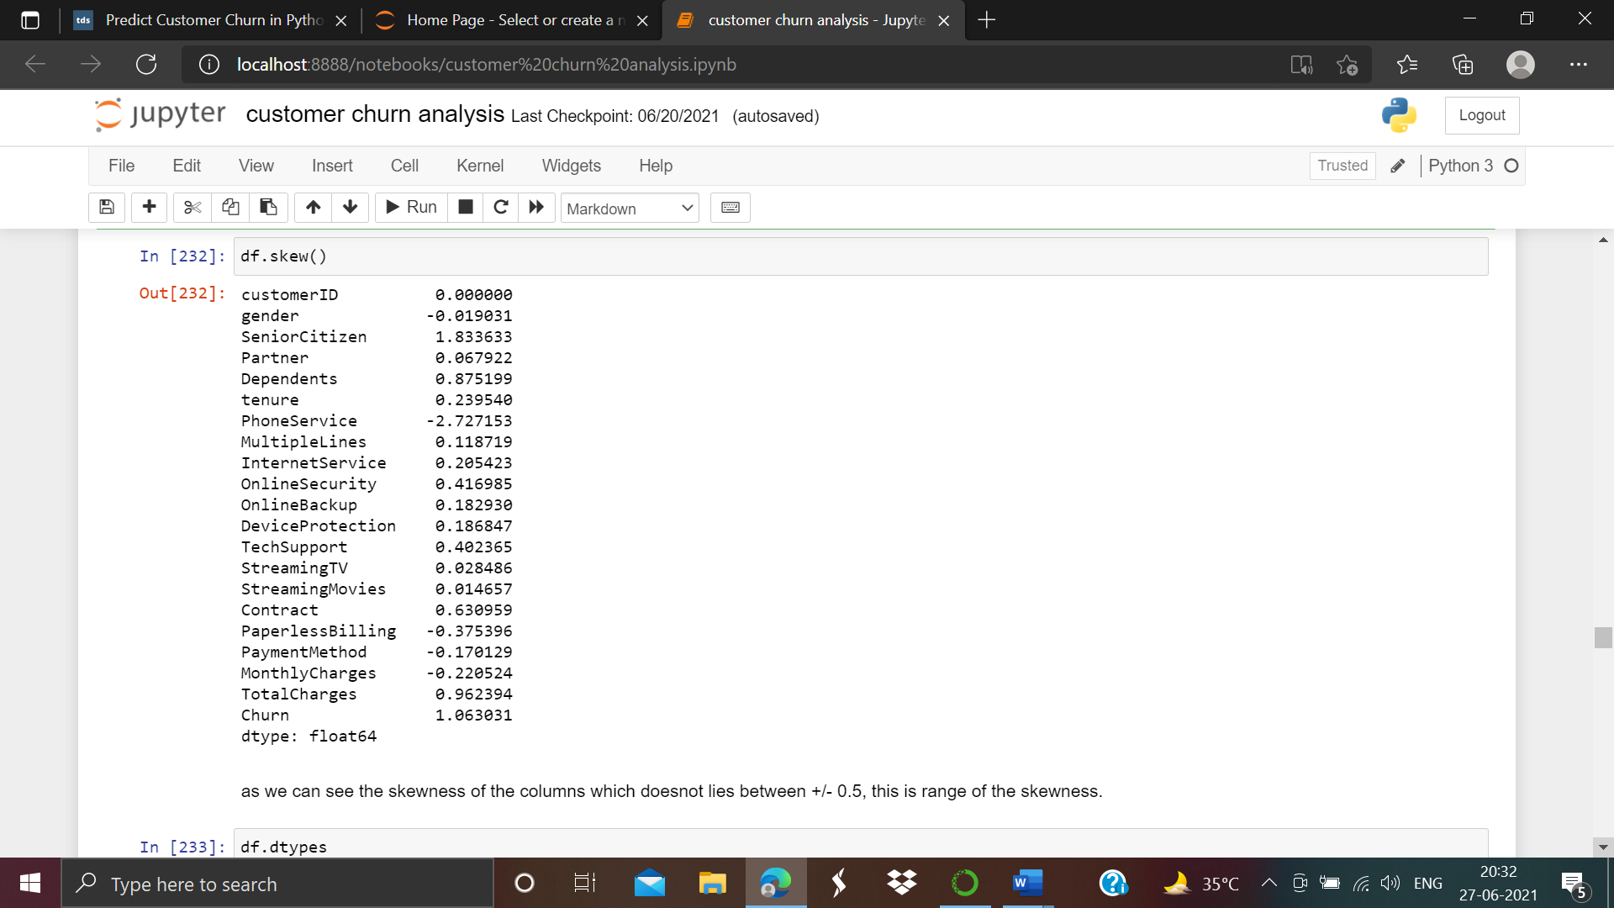

as we can see the skewness of the columns which does not lies between +/- 0.5, this is range of the skewness.

**Outliers check**

To find the outliers present in our dataset we are going to use box plot visualization on integer and float types of columns.

Let’s have a look for this

df['SeniorCitizen'].plot.box()

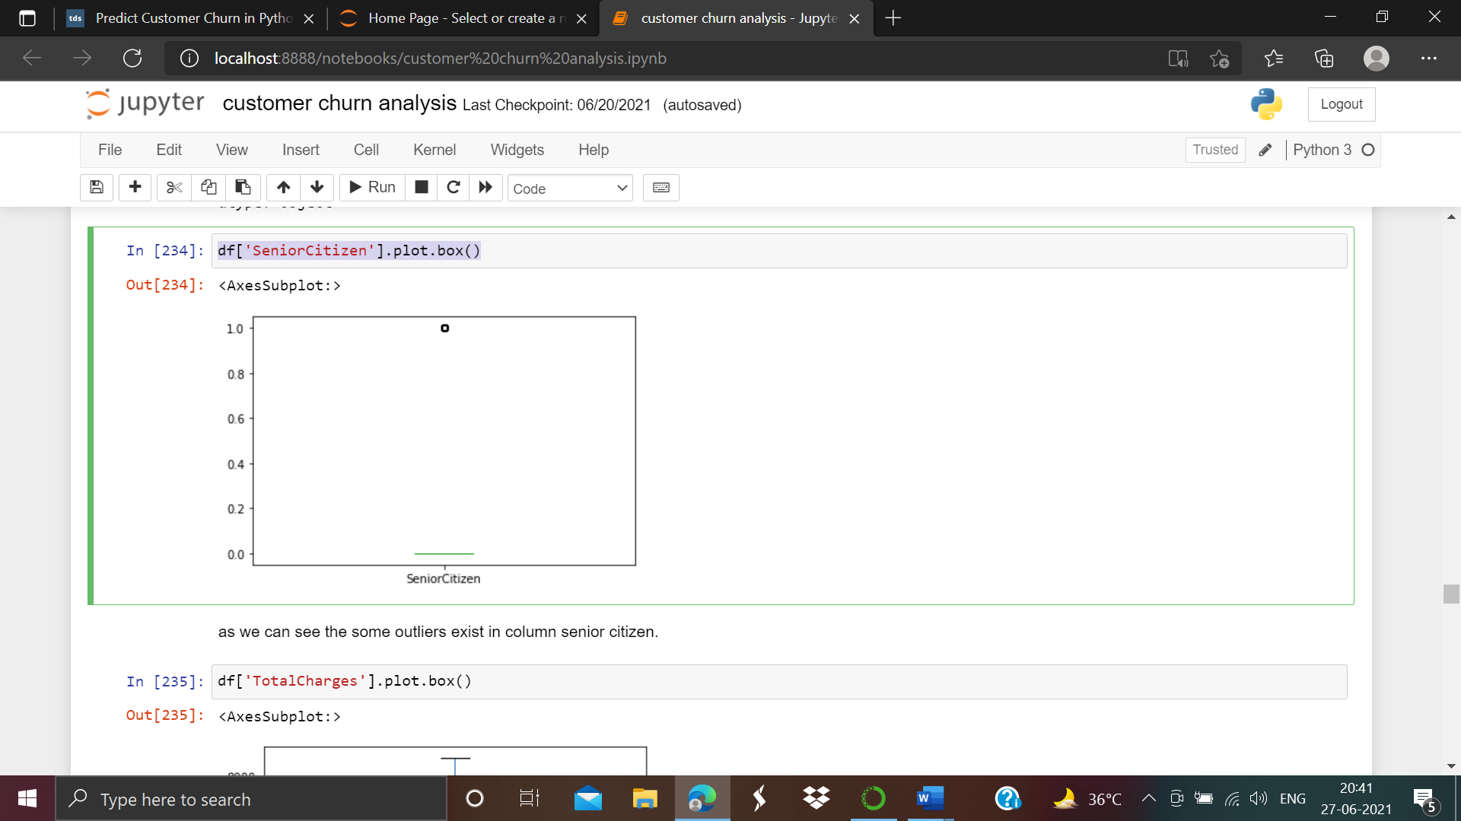

df['TotalCharges'].plot.box()

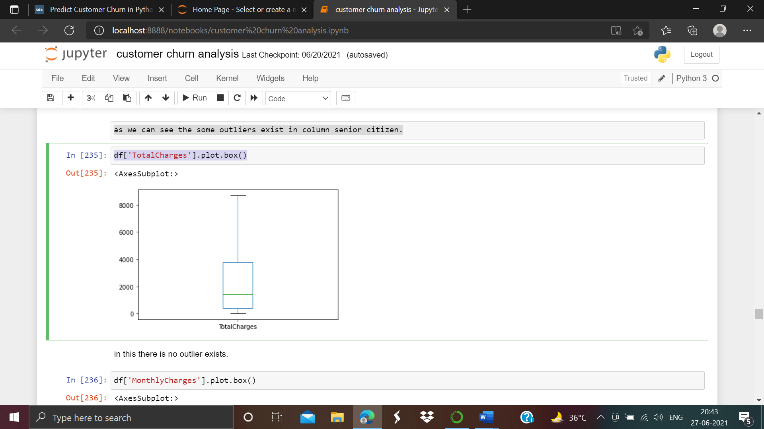

df['MonthlyCharges'].plot.box()

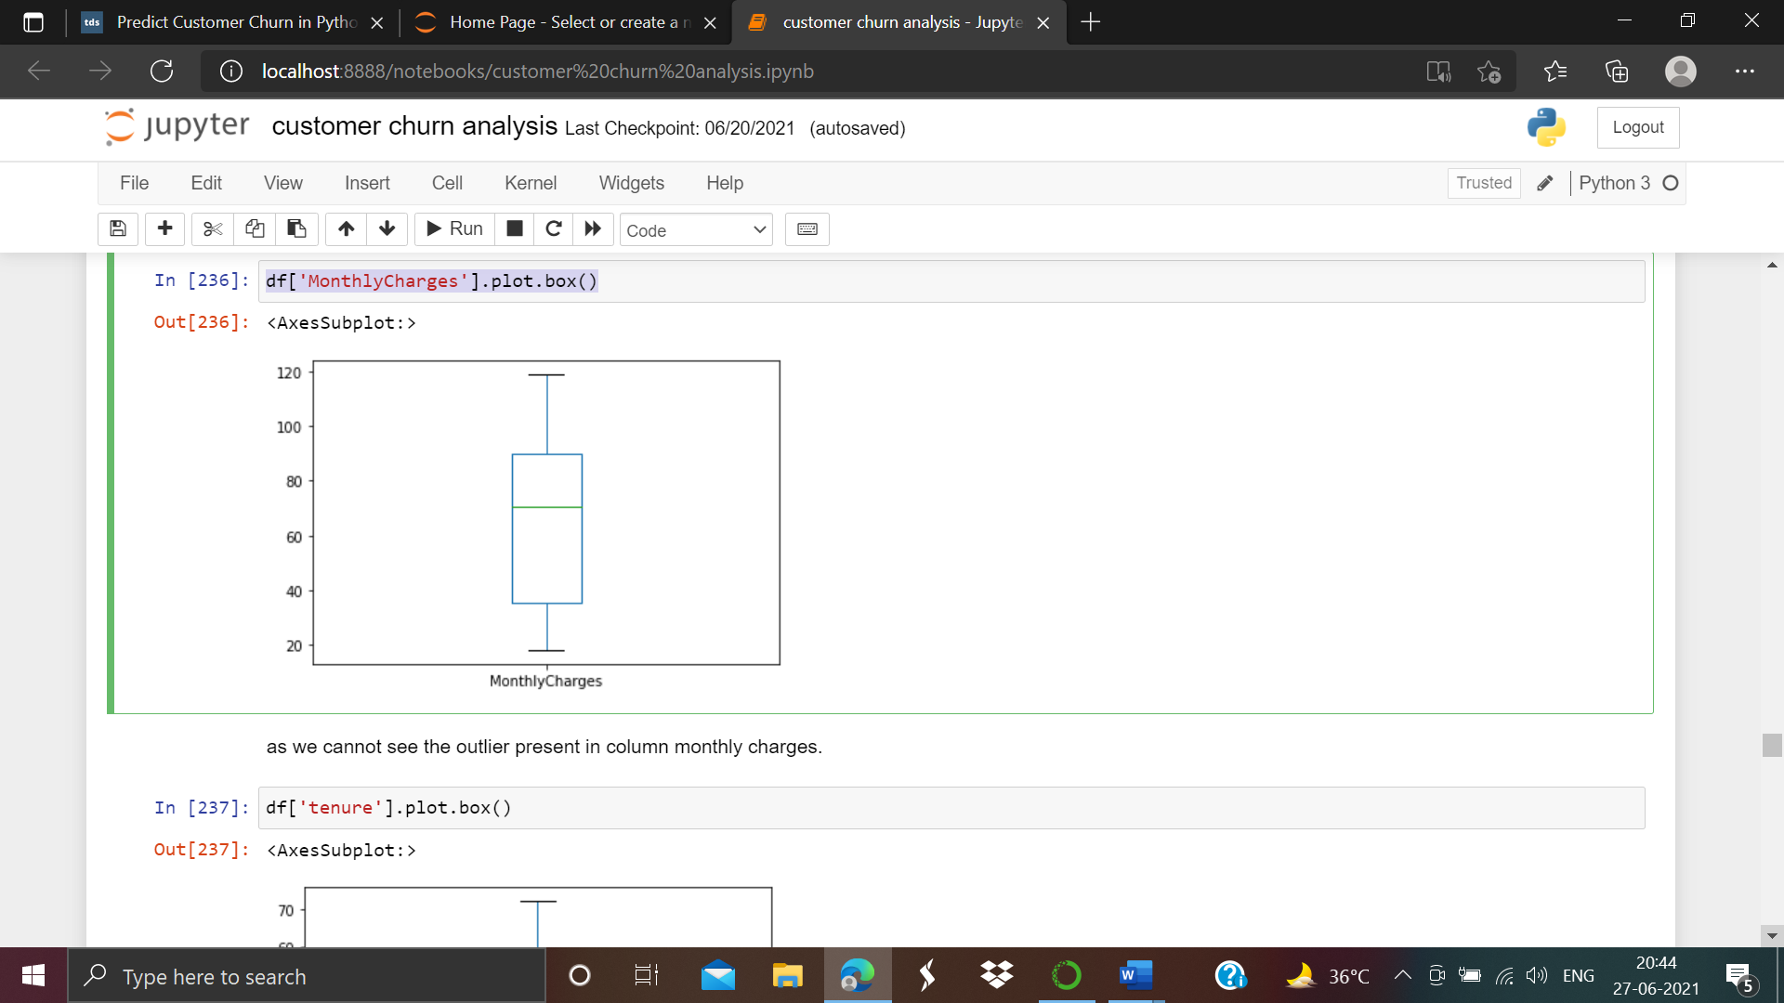

df['tenure'].plot.box()

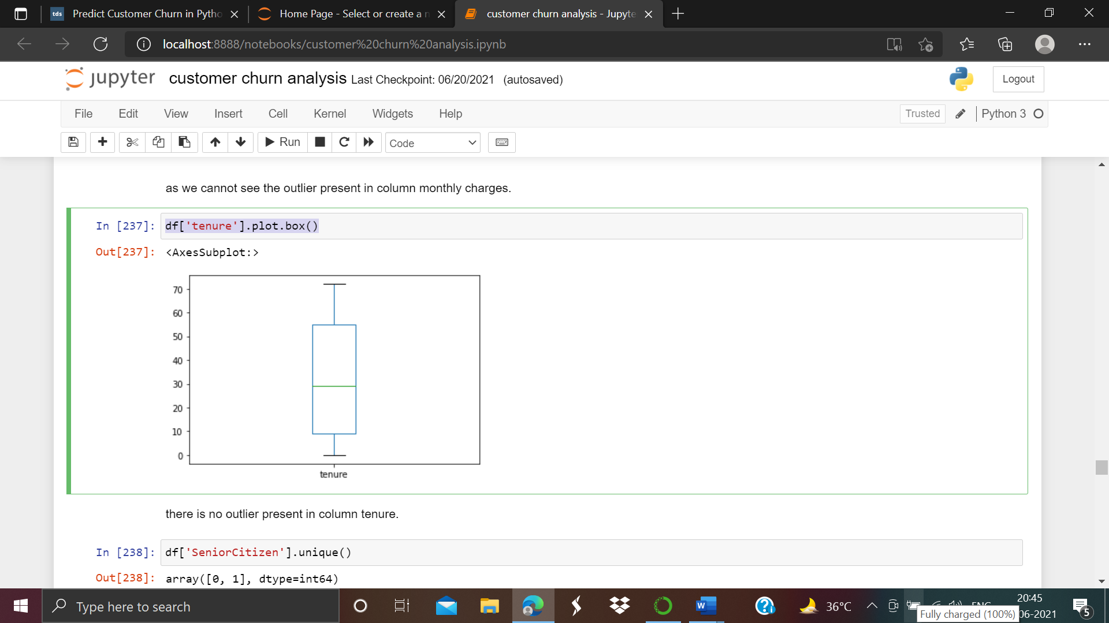

As we can see the outliers present in senior citizen column. So we have consider on this. So we have to determine the unique value present in this particular type of column.

df['SeniorCitizen'].unique()

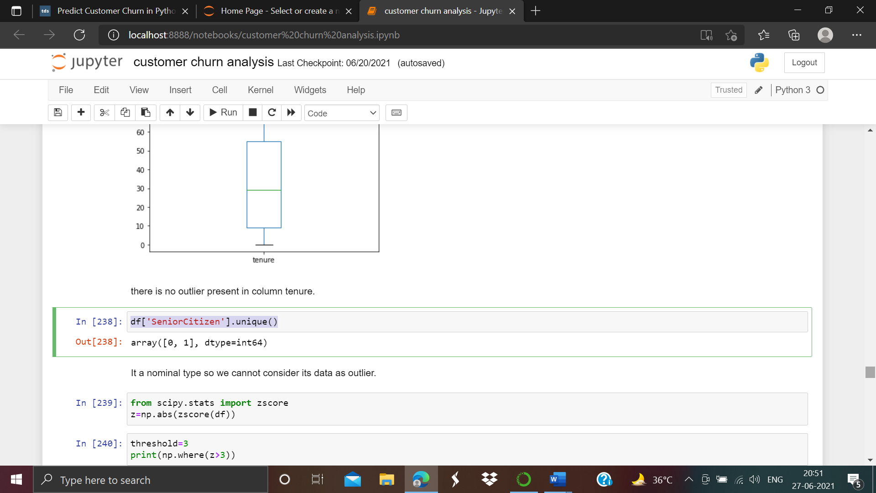

It’s a nominal data type that’s why we can not consider its data as an outlier.

**Z score Calculation**

Now we have to considering on outlier removal. So we have to consider the z score calculation.

First of all we have to import z score from scipy.stats, As screen shot is given below:-

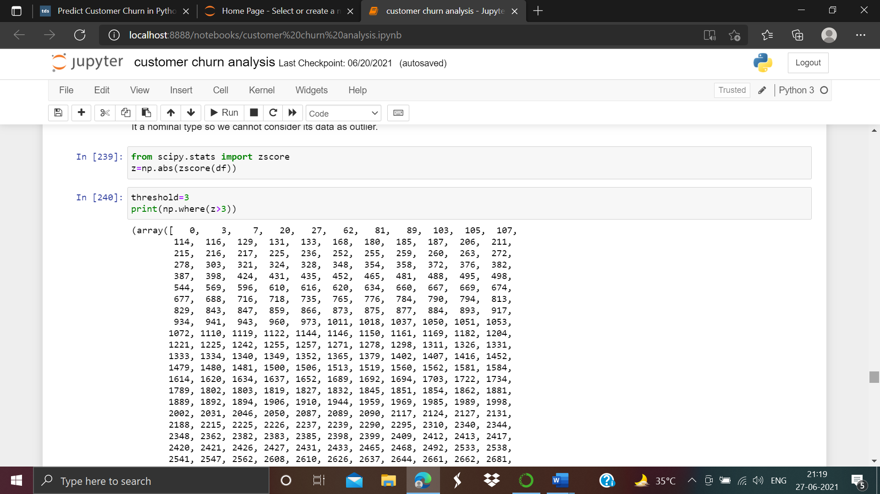

This shows the z score value when zscr>3 and threshold value is equal to 3.

z[4981][3]

z score value is 0.9666223112813243

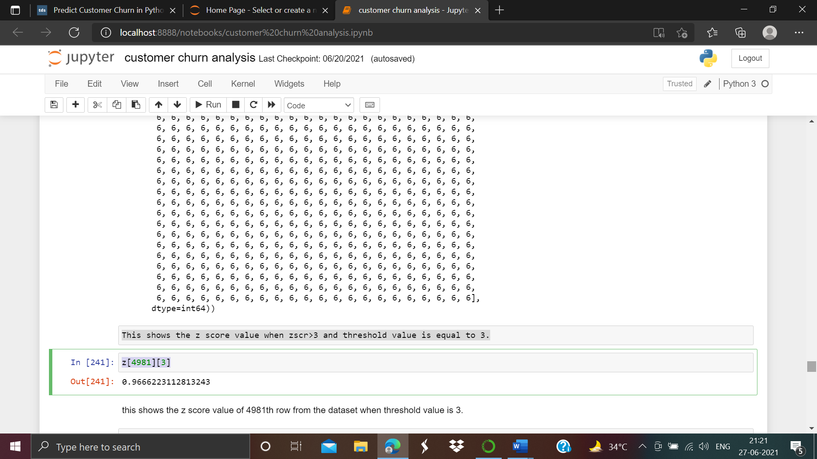

As we can see the z score value of 4981th row from the dataset when threshold value is 3.

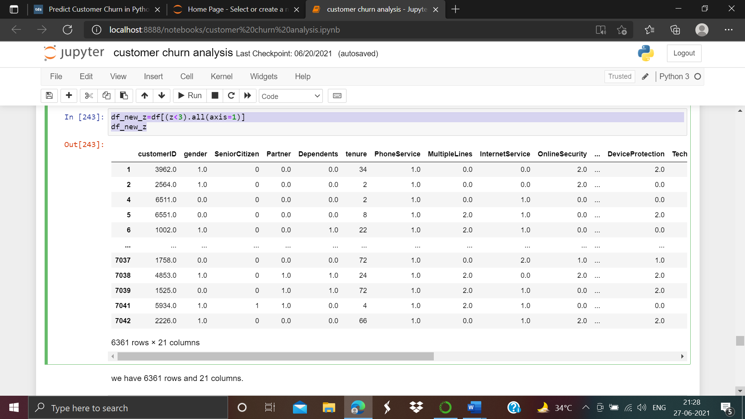

In this we have 6361 rows and 21 columns now.

**Data Loss Prediction**

After considering of outlier removal now we need to know how much data information we have lost. For this we have applied this formula into our practice:-

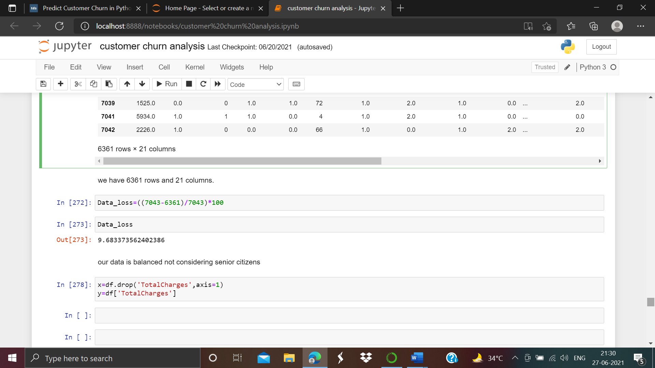

From the above we can see we have lost approx. 9.68% data from the dataset.

**Separating the columns into features and target**

Now we are going to separating the columns of our dataset into features and target. So we will drop the “TotalCharges” from the dataset as shown below:-

1. **Building Machine Learning models**

x=df.drop('TotalCharges',axis=1)

y=df['TotalCharges']

**Scaling the data using Min-Max Scaler**

**Spiliting the dataset**

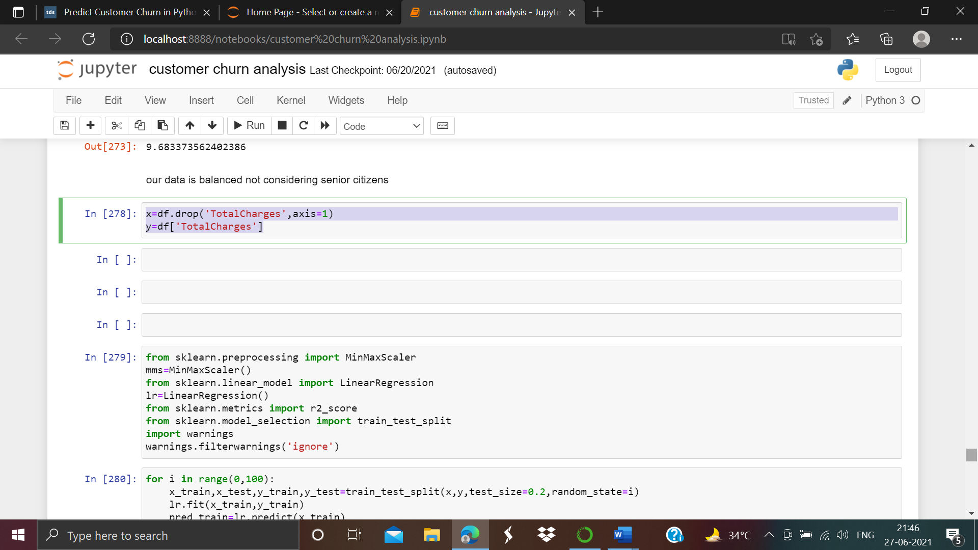

From the above we used Min-Max scaler and split the dataset into train test split.

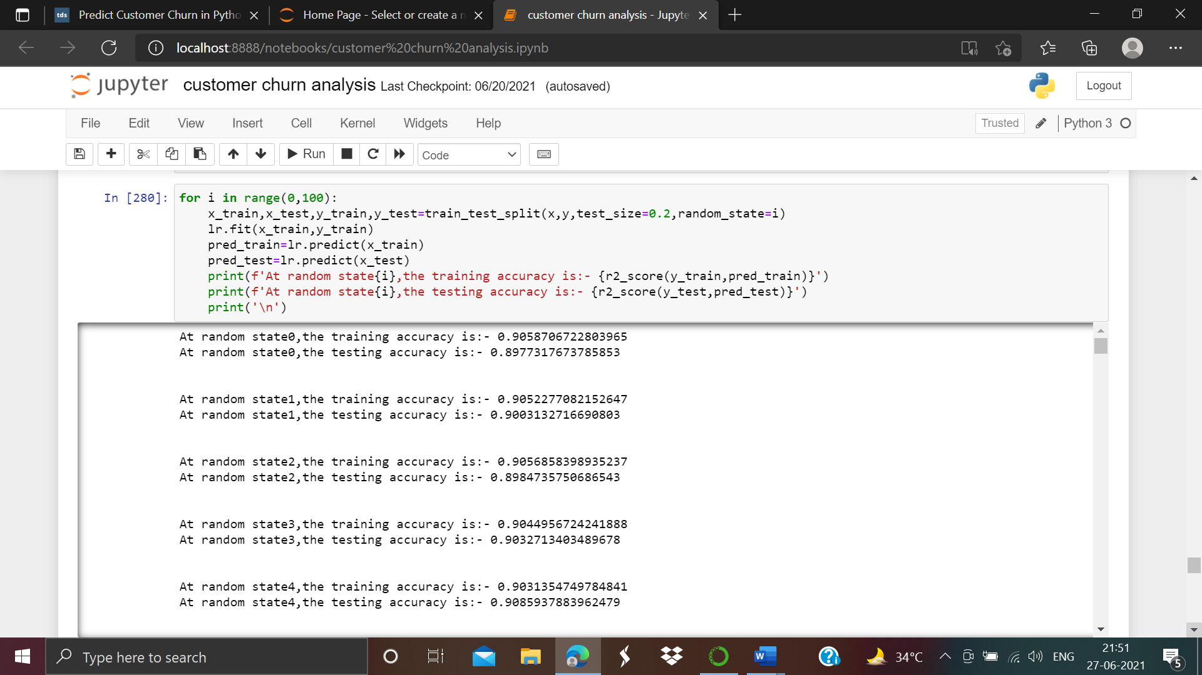

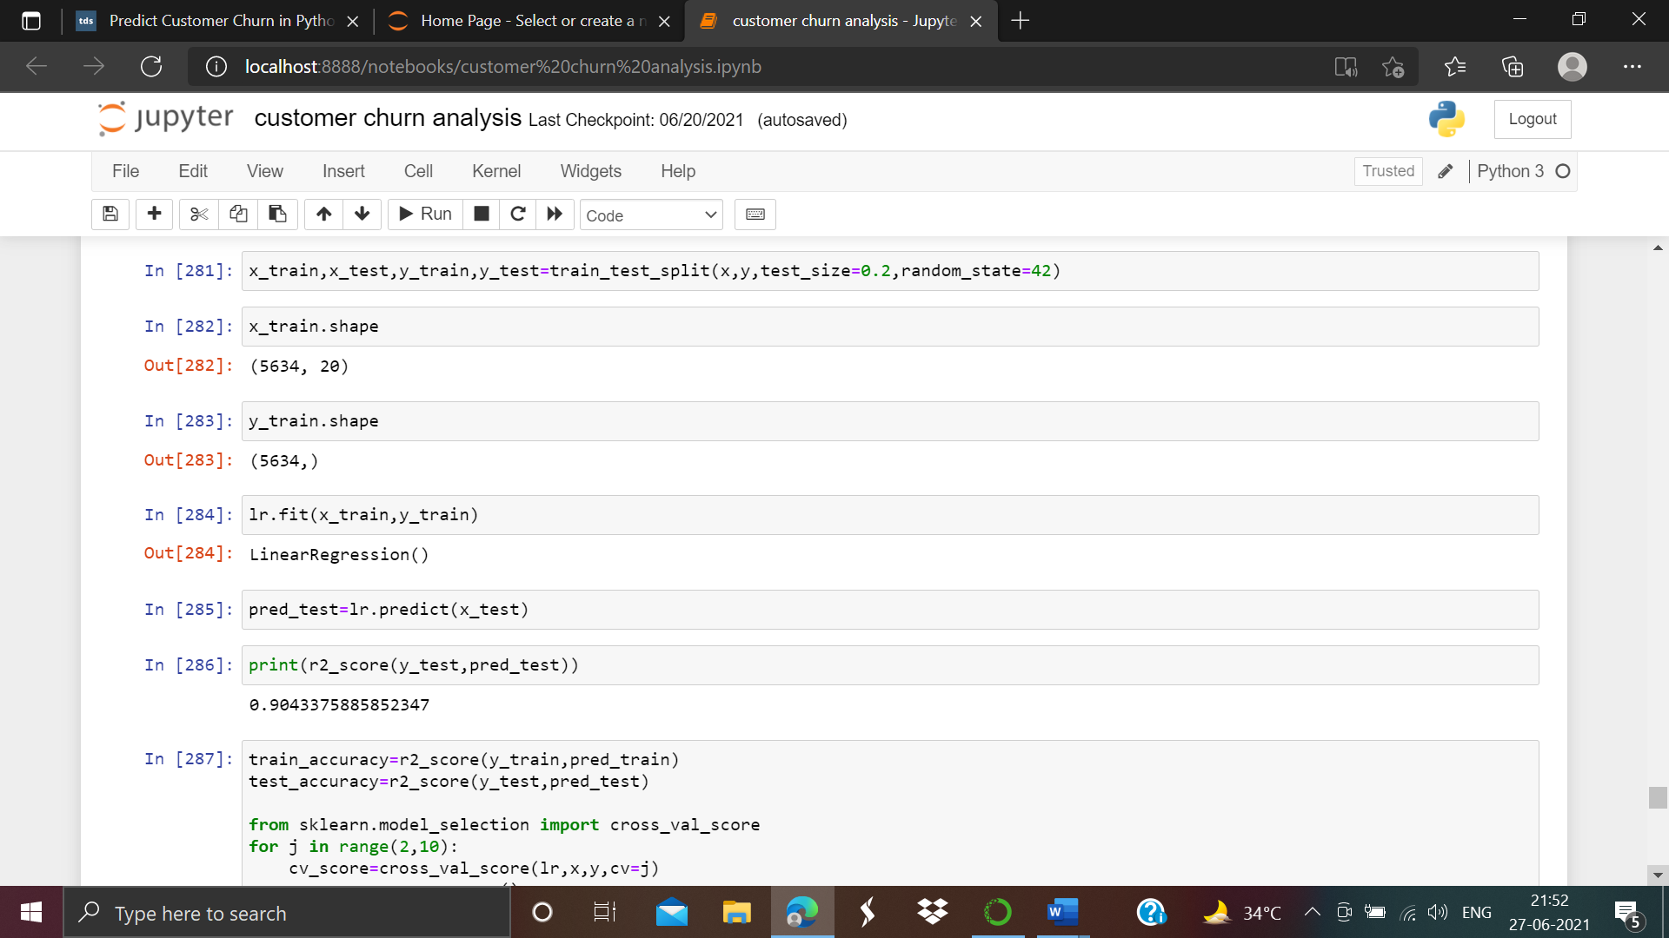

As we can see the R2 score of Linear regression is 0.9043375885852347

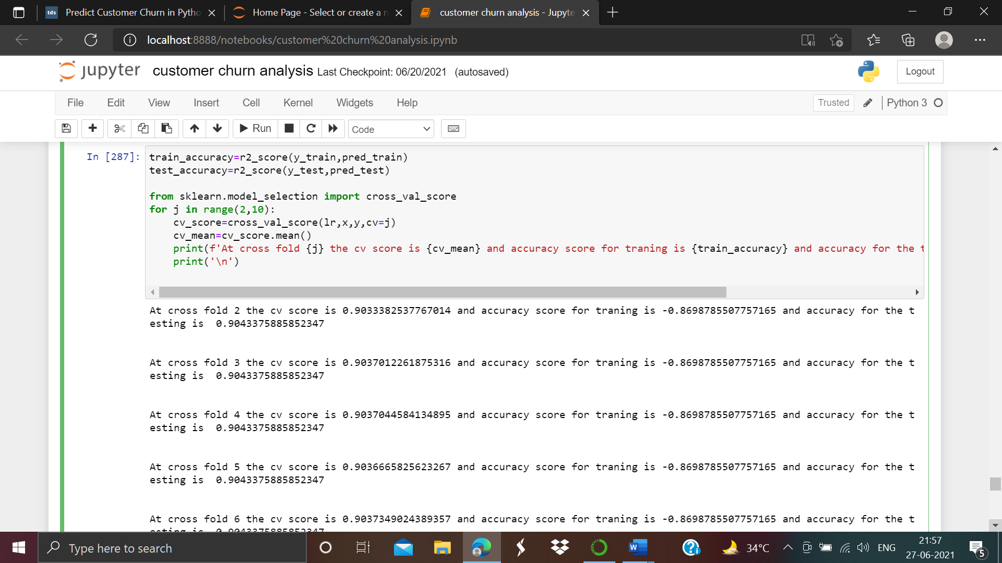

**At cross fold 2 the cv score is 0.9033382537767014 and accuracy score for training is -0.8698785507757165 and accuracy for the testing is 0.9043375885852347**

**Ensemble technique:**

Now we are going to use ensemble techniques in the project. We have to import some regressor libraries from sklearn.model_selection and we have to select our best model also. As shown below:-

We will use the First Random forest Regressor and then we will apply the Decision Tree Regressor Technique.

1. **Random forest Regressor**

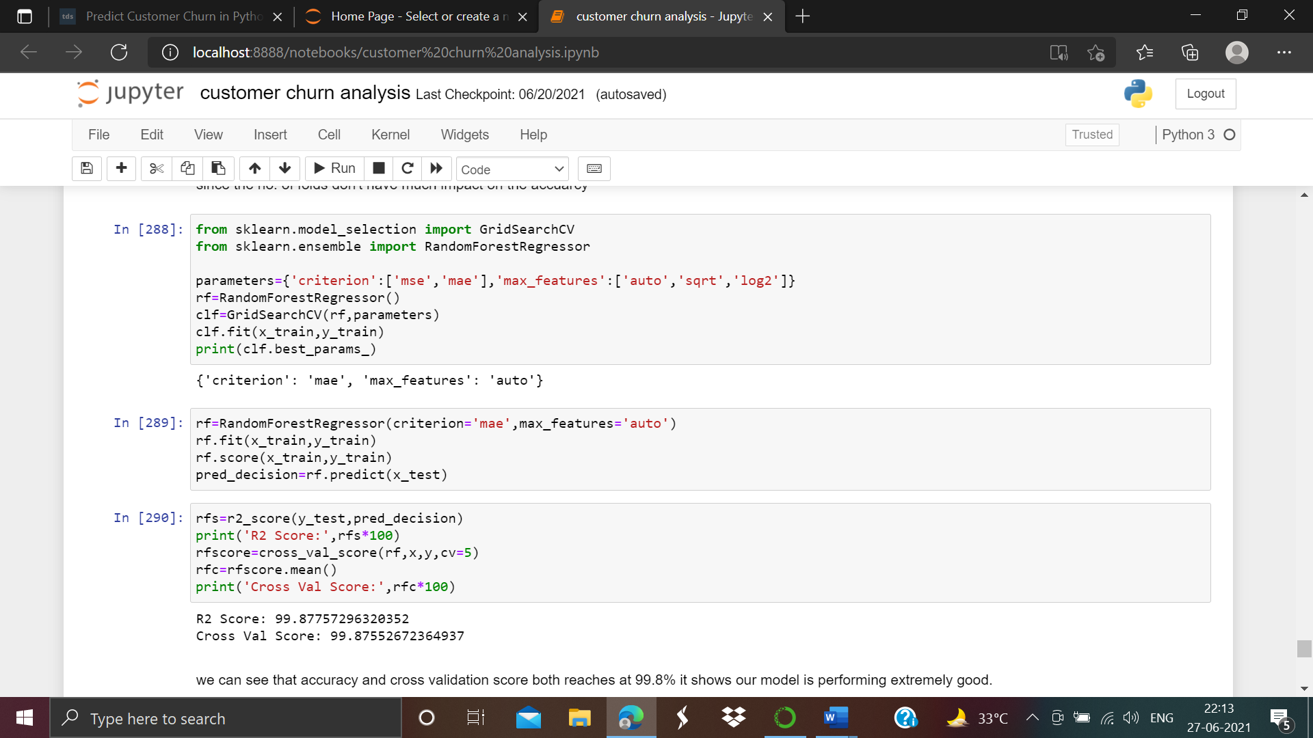

We observed from the above that accuracy and cross validation score both reaches at 99.8% it shows our model is performing extremely good.

1. Deci**sion Tree Regressor**

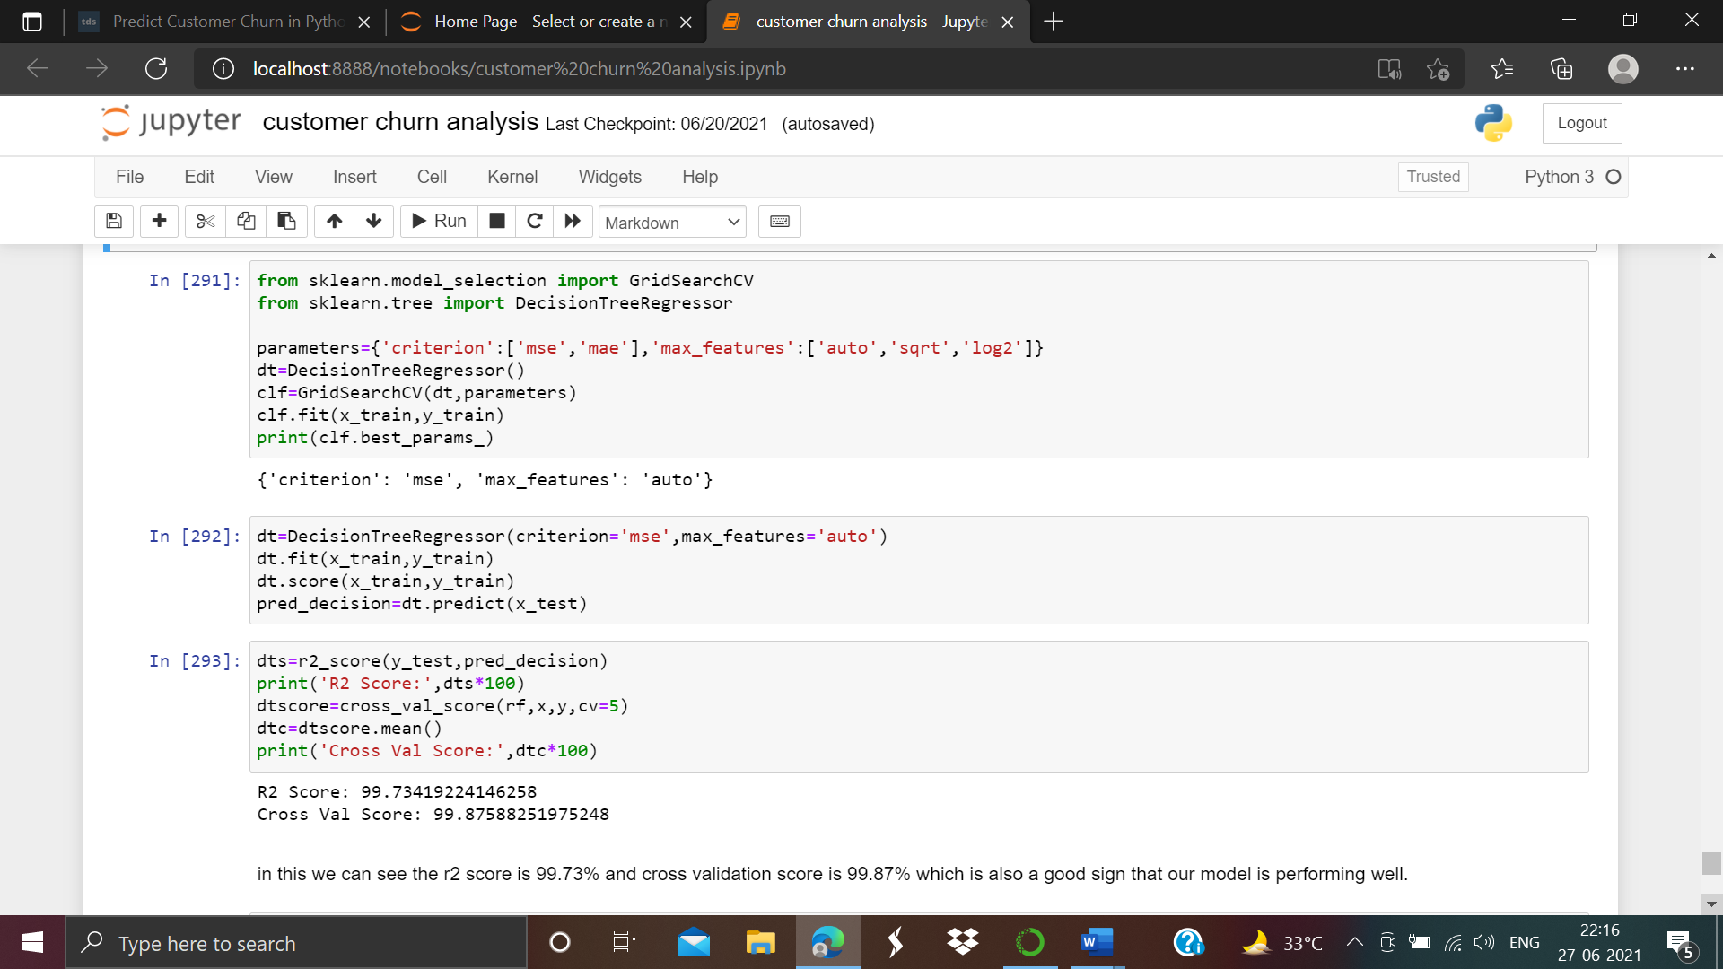

in this we can see the r2 score is 99.73% and cross validation score is 99.87% which is also a good sign that our model is performing well.

**Saving and load the model**

Finding an accurate machine learning model is just not the end of the project. We also save and load the our model in proper format. This will gives us the brief idea to save our model to file and load it later to make better predictions.

In this project we have used pickle operation which is useful for some machine learning algorithms that requires a lot of parameters or we can say store the entire dataset.As screen shot attached below:-

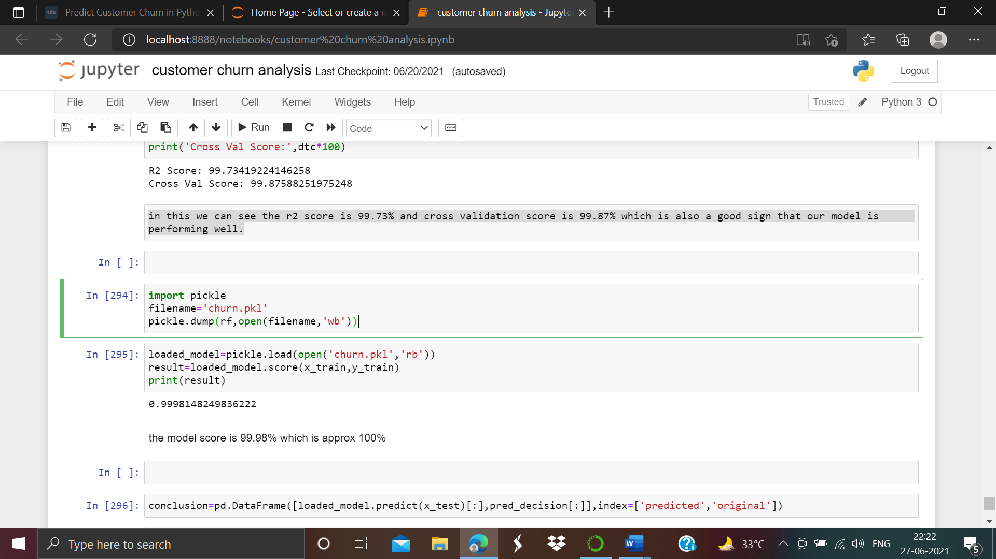

As we can see above we have saved our model to file as ‘churn.pkl’ format

After the model is loaded we have to estimate the accuracy of our best model.

The accuracy of our best model is 99.98% which is approx. 100 %

1. **Conclusion**

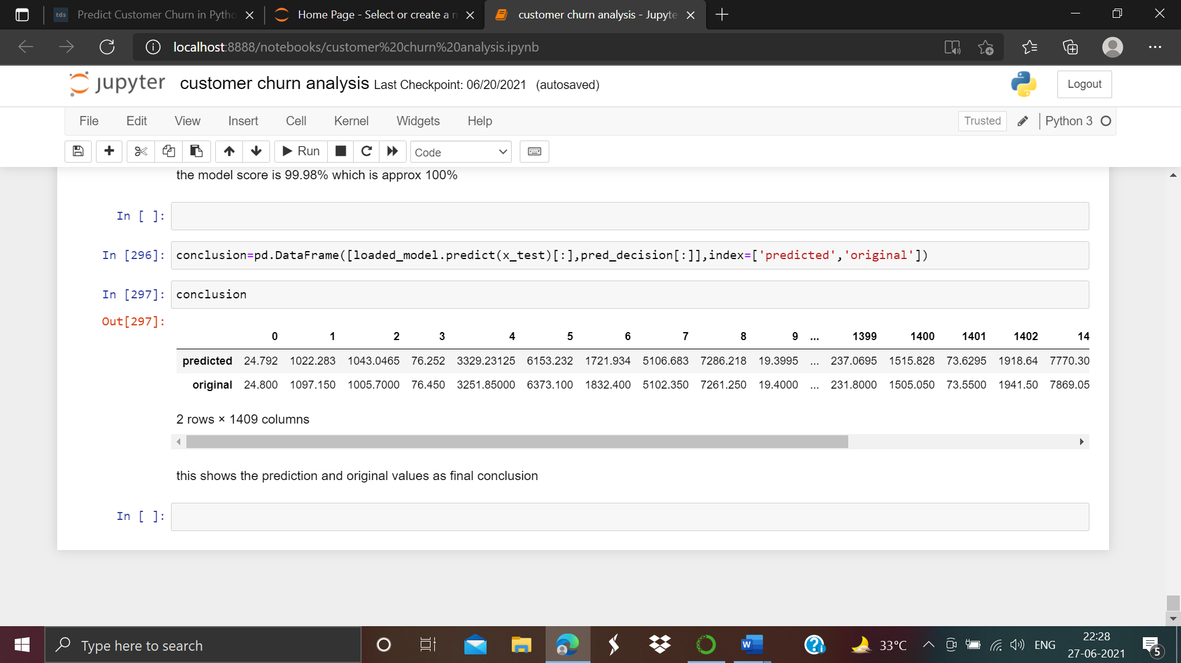

As shown above we have predicted the our decisions as ‘predicted’ and ‘original’. As we can see above we have separate different-2 predicted and original values respectively.

This shows the predicted and original values which we are having we consider that as final conclusion.